**Description**

You can use Azure Database Migration Service to migrate the databases from a SQL Server instance to [Azure](https://github.com/MicrosoftDocs/azure-docs/blob/main/azure/sql-database) SQL Server. In this tutorial, you migrate the [Sample](https://github.com/MicrosoftDocs/azure-docs/blob/main/sql/samples/adventureworks-install-configure#download-backup-files) (Adventure Works) database from SQL Server 2019 to Azure SQL Server Manged Instance by using Azure Data Studio

In this Lab, you will learn how to:

* Use the Azure Data Studio to migrate the database sample data.
* Create a migration project by using Azure Data Studio.
* Run the migration.
* Monitor the migration.

**Learning Objectives**

Upon completion of this Lab, you will be able to:

* Migrate Azure SQL Server to Azure SQL Managed Instance (IaaS to PaaS)
* Connect to an Azure SQL database and SQL server through Azure Data Studio

**Intended Audience**

This lab is intended for:

* Microsoft CSA Team members

**Steps to carry out migration activity**

Login to Source VM by **RDP**

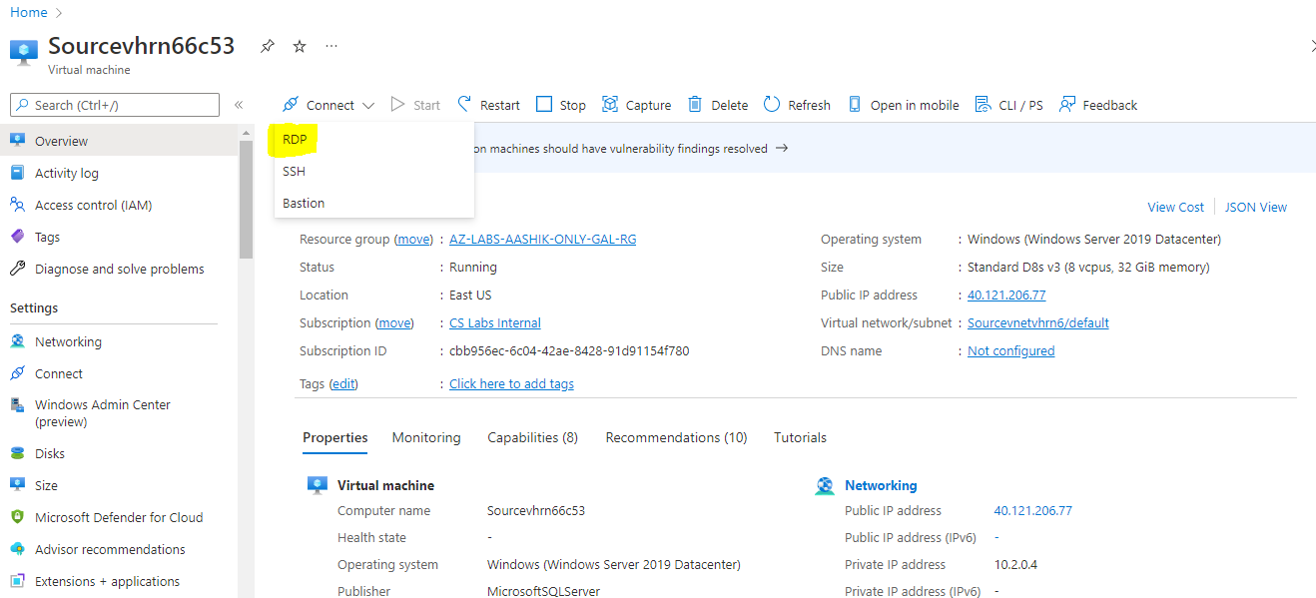

Select **Download RDP**

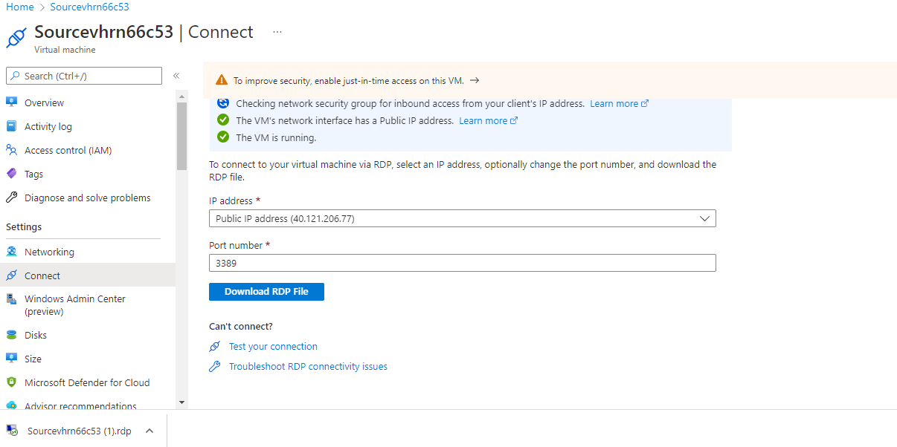

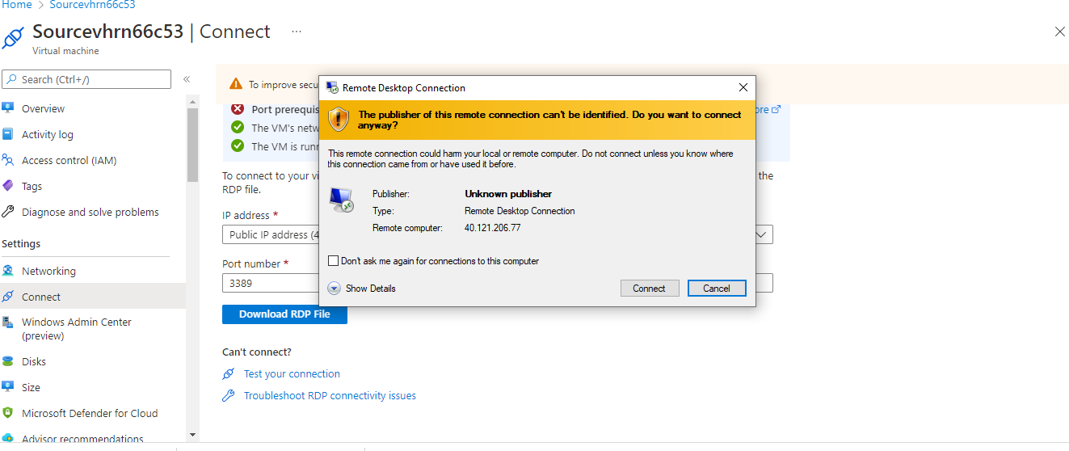

Provide **SQL Username**: sqladmin and **Password: Password@123**

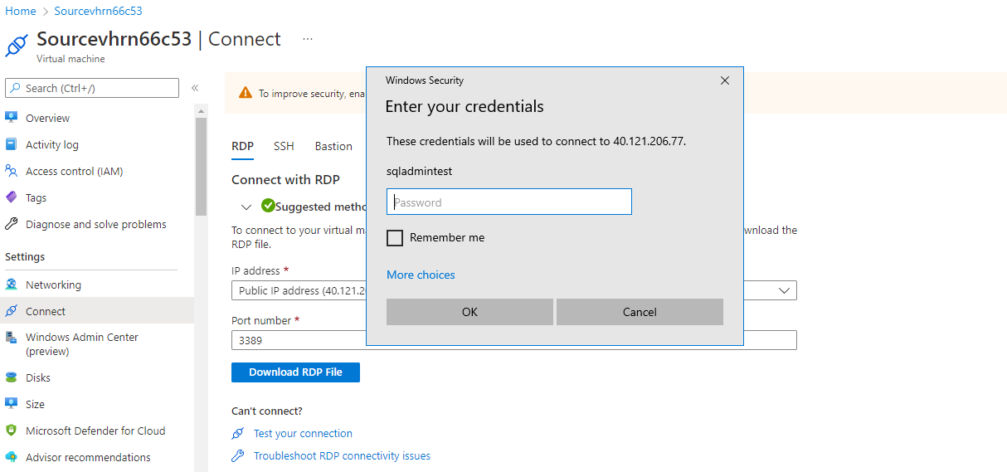

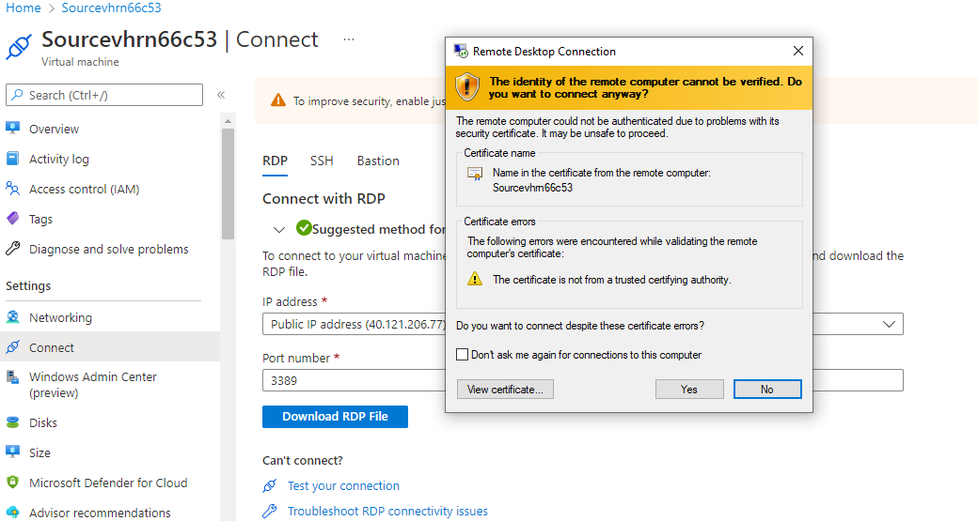

**After Login to SQL Source VM disable IE Enhanced Security Configuration**

Search for Server Manager, Go to Dashboard and choose Configure this local server.

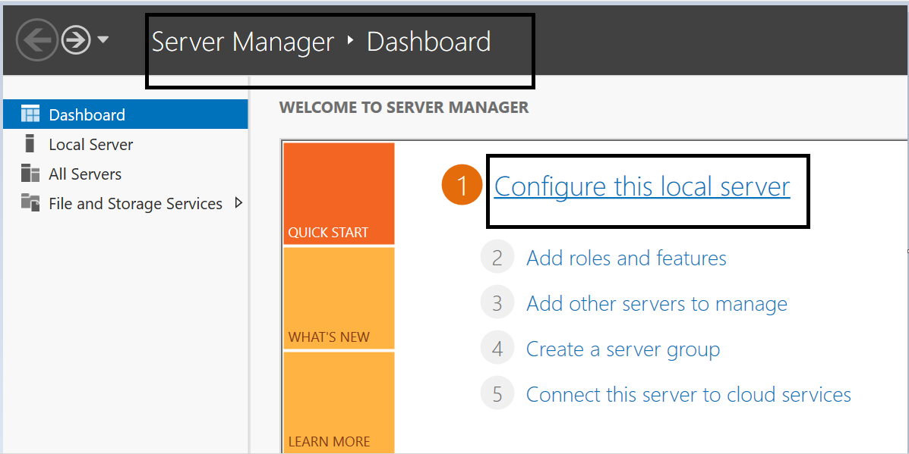

In properties pane navigate to IE enhanced security configuration and click on **On**.

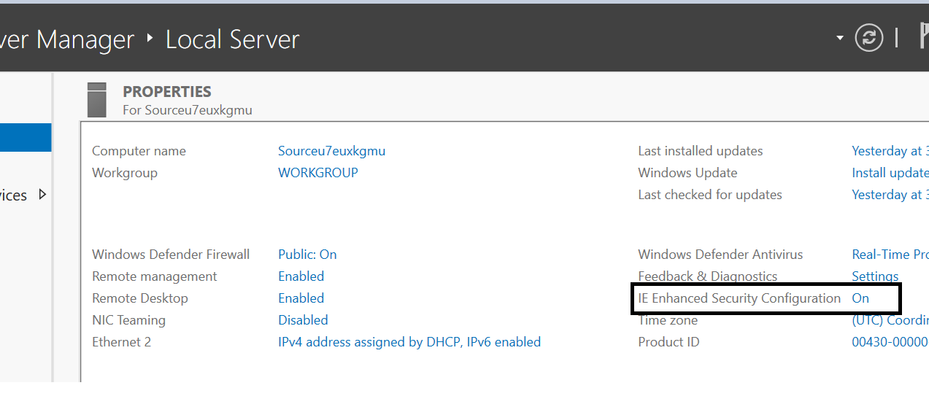

Choose **Off** in both options and click on save. (These steps help in seamless login to azure subscription through Azure data studios).

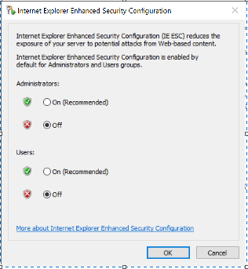

**Online Data Migration Steps:**

Search **Azure Data Studio** and Launch.

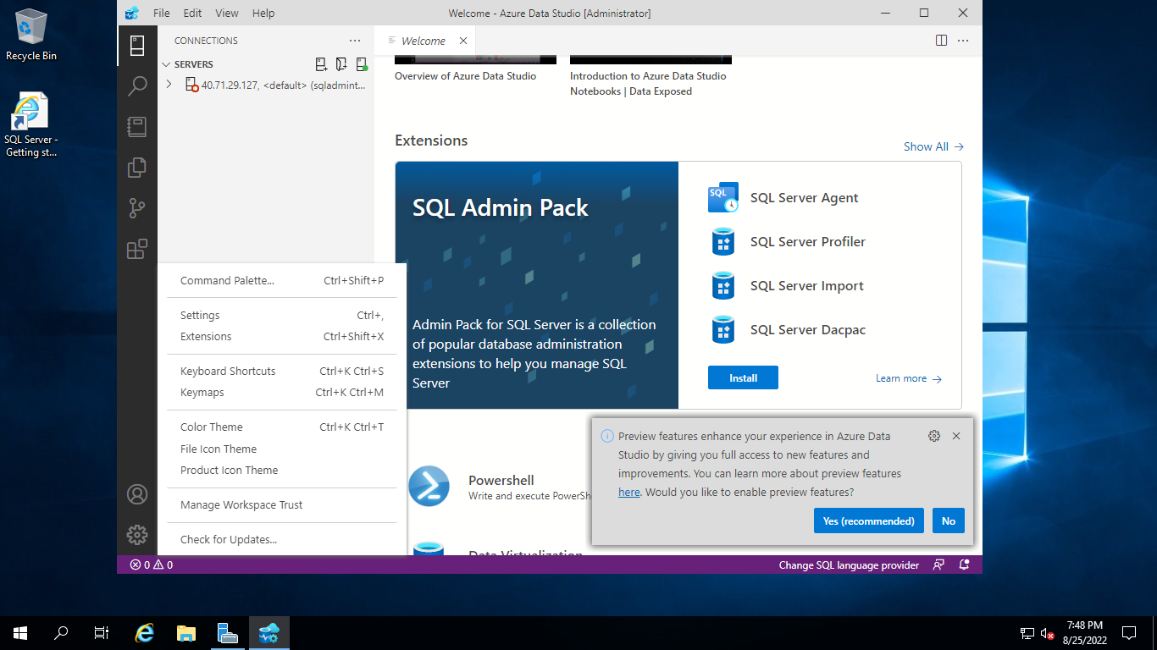

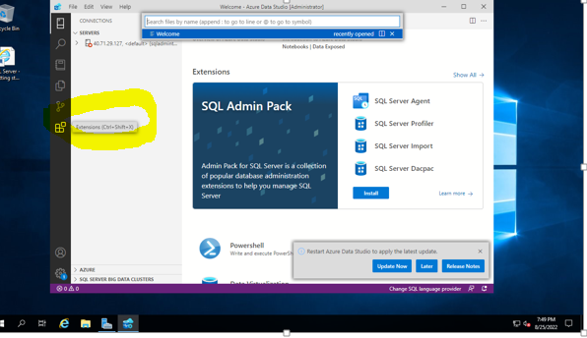

Go to **Extensions**

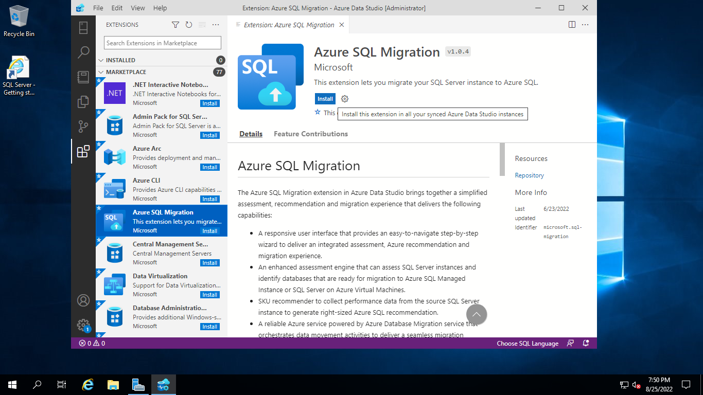

Select **Azure SQL Migration** Extension and Install

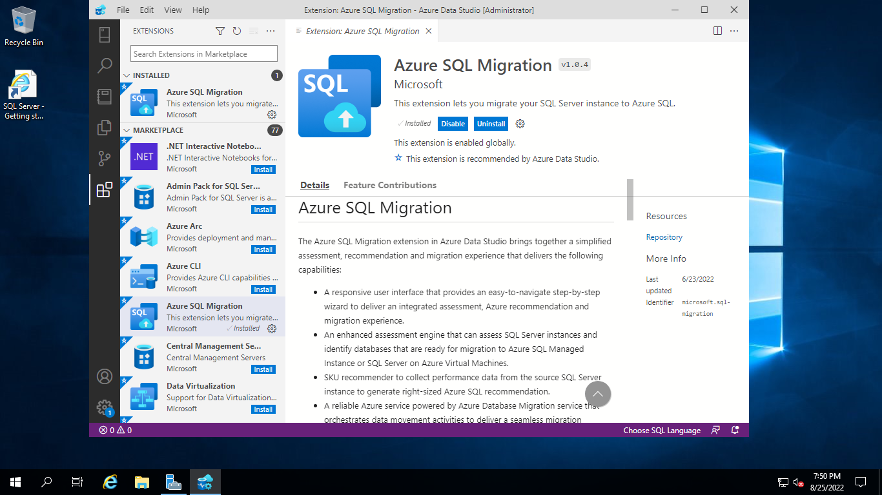

Then go to **Command Palette**

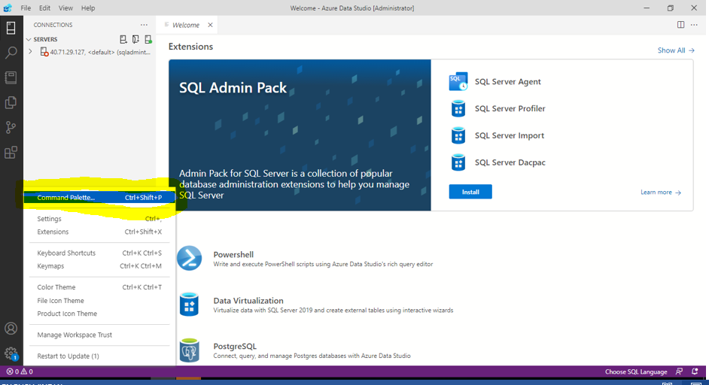

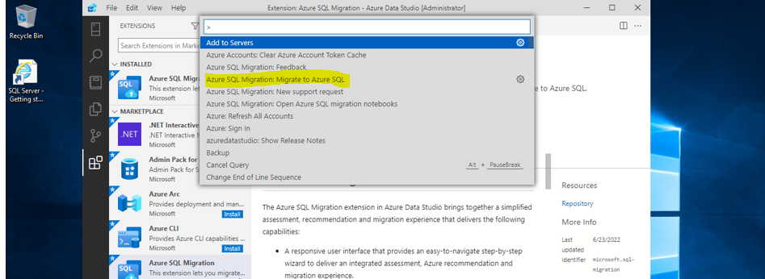

Type Azure SQL Migration: **Migrate to Azure SQL then Enter**

Provide Source Server **Public IP address**

Authentication Type: **SQL Login**

Provide SQL Username: **sqladmin** and Password: **Password@123**

Select **Connect**

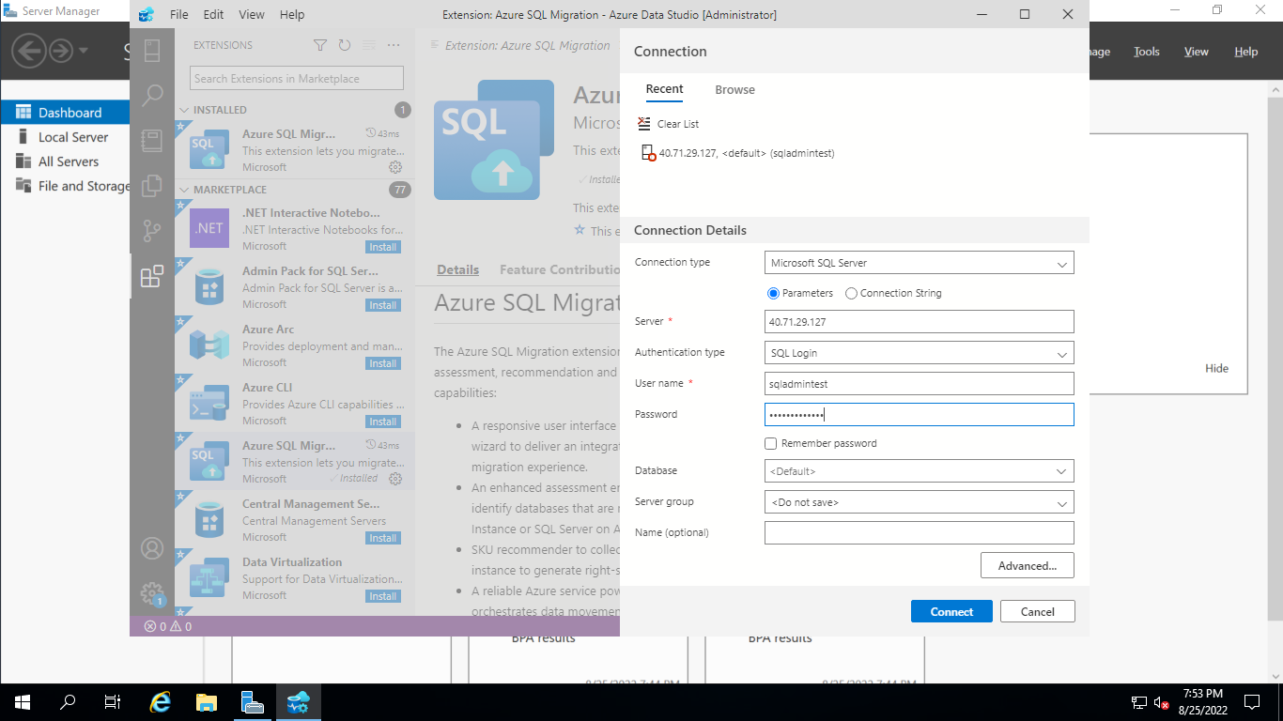

Select **SampleDatabaseForOnline**

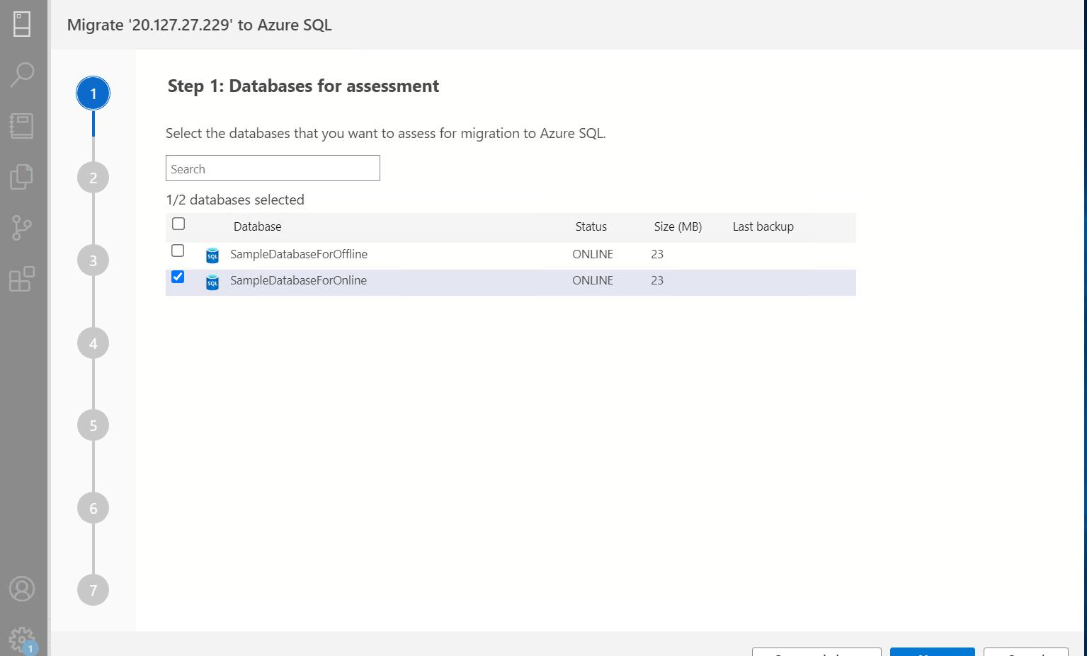

Select **Azure SQL Managed Instance**

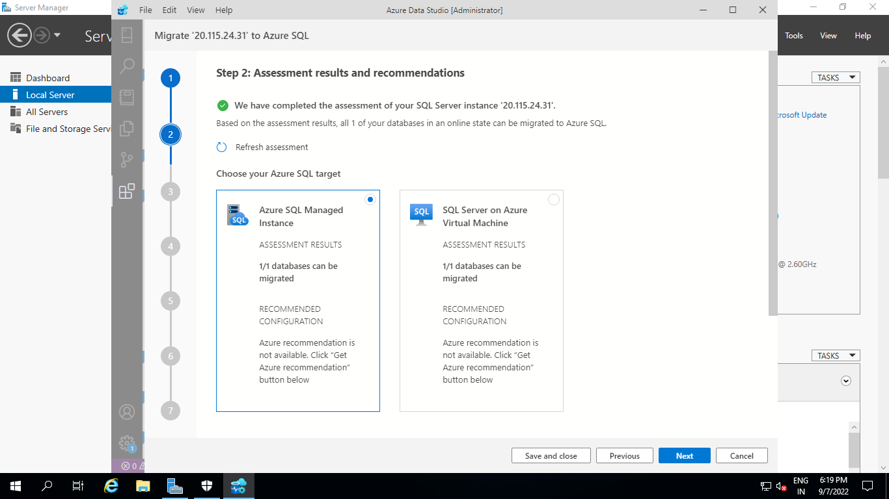

Then Select **View/Select**

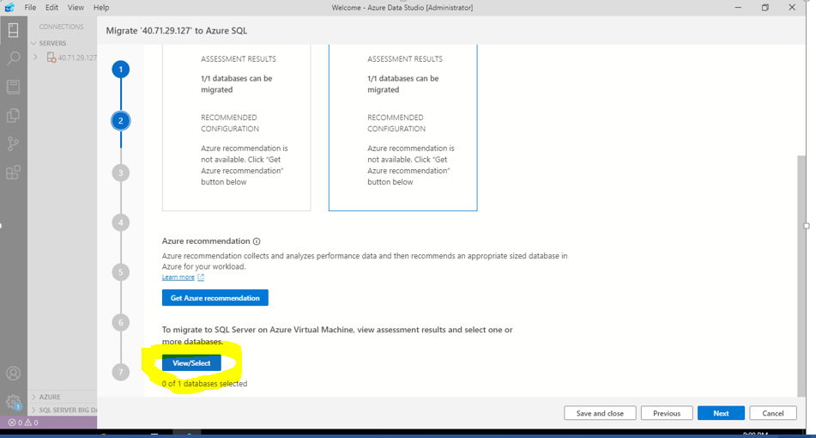

Select **SampleDatabaseforOnline**

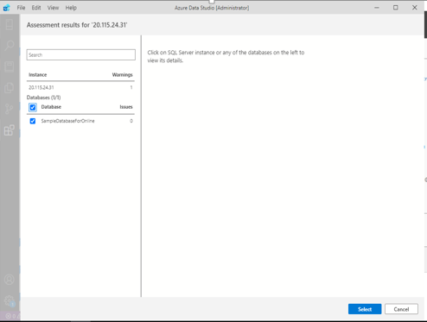

Click **Next**

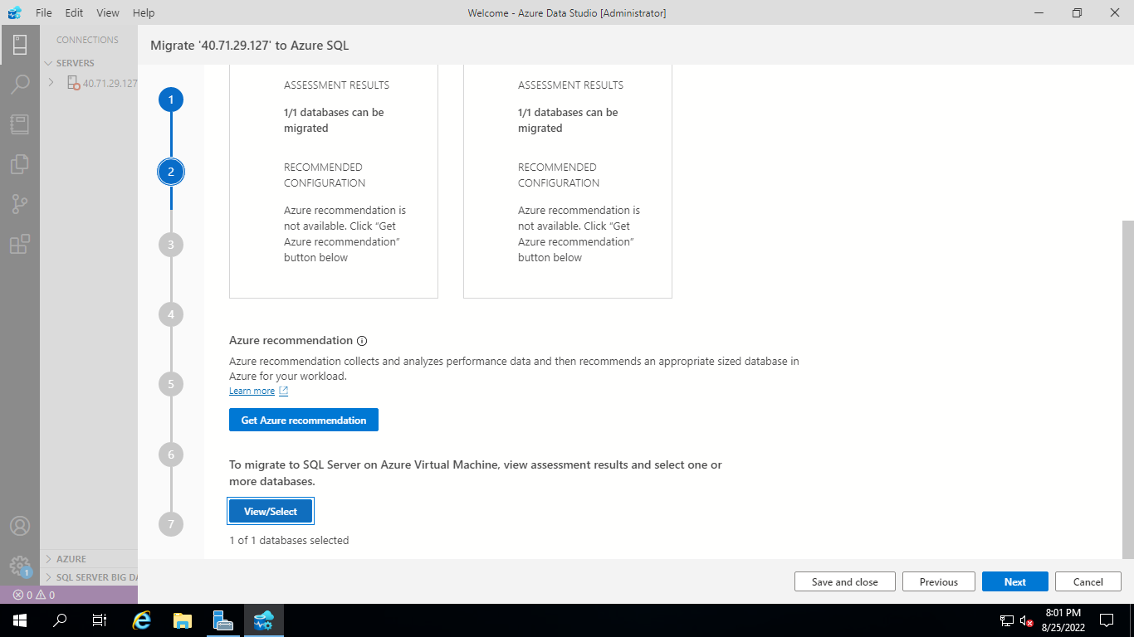

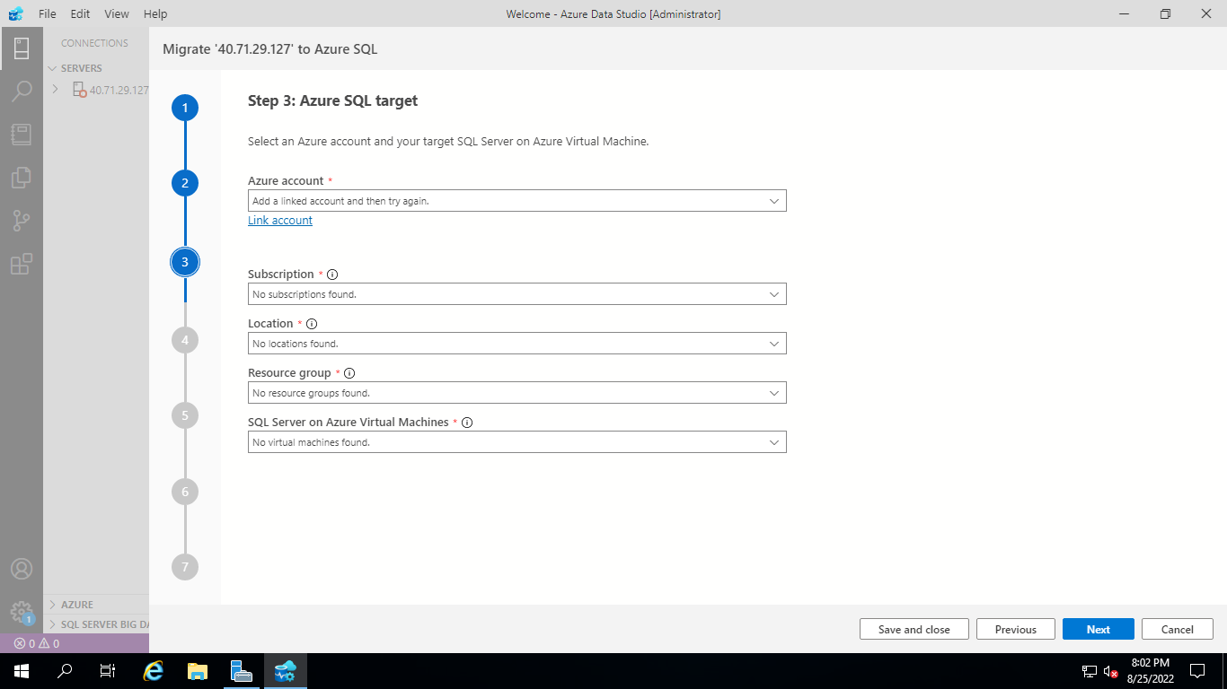

Provide **Azure SQL Target** fields

Azure Account: Link Account with Azure login details

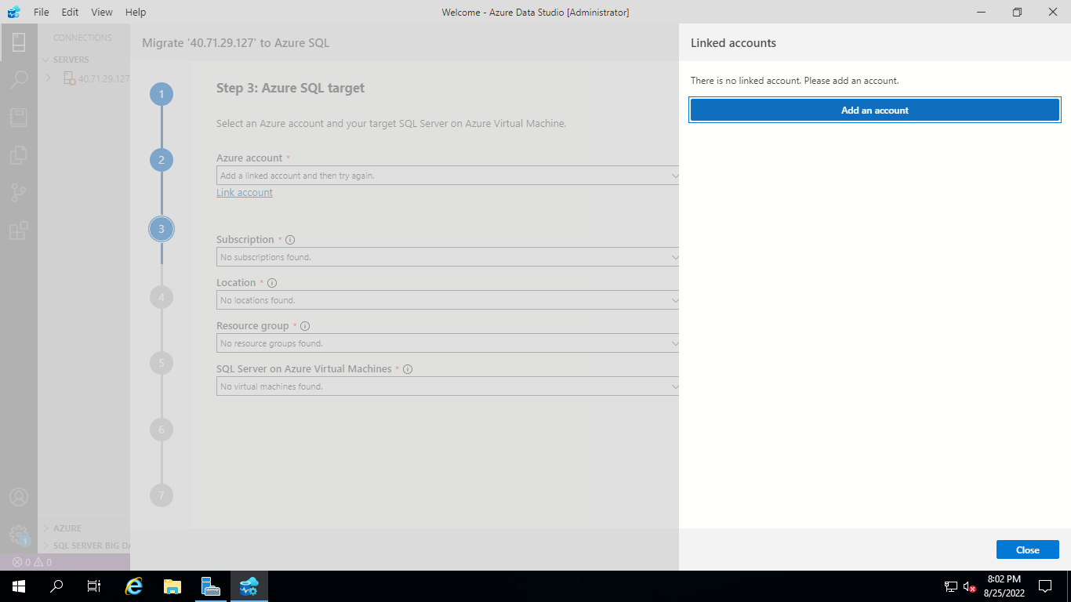

Click on **Add an Account**

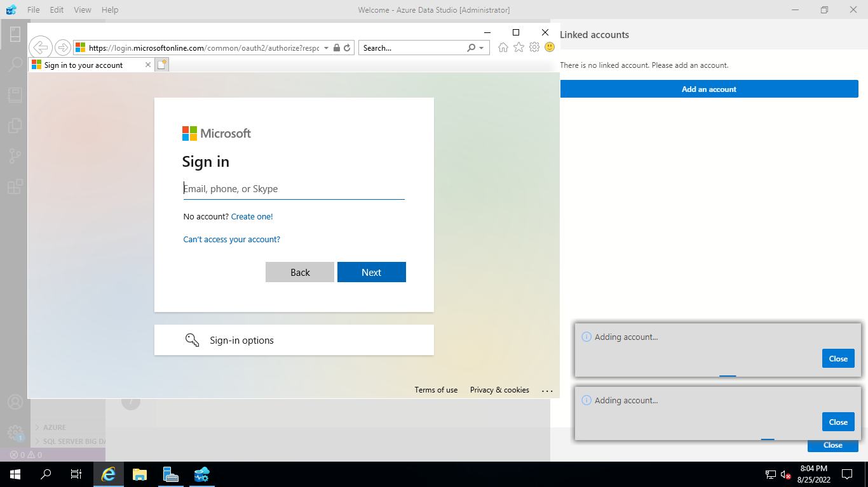

Provide **Azure Portal Login** Details

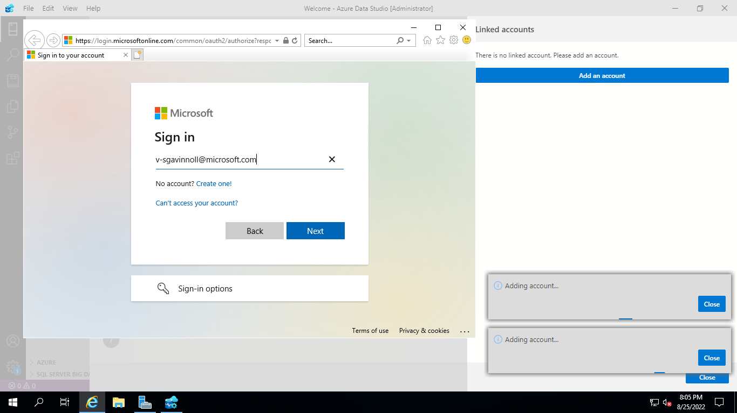

Close once you add your account

Select Target SQL MI Details:

**Subscription: Subscription Name**

**Location: East US**

**Resource Group: Target VM Resource Group**

**Azure SQL Managed Instance: Target SQL Managed Instance Name**

Select Next

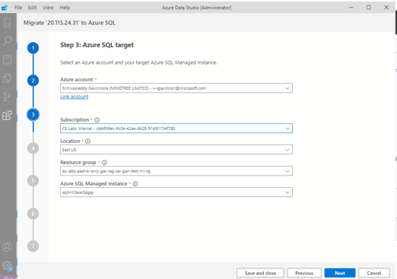

Select **Online migration**

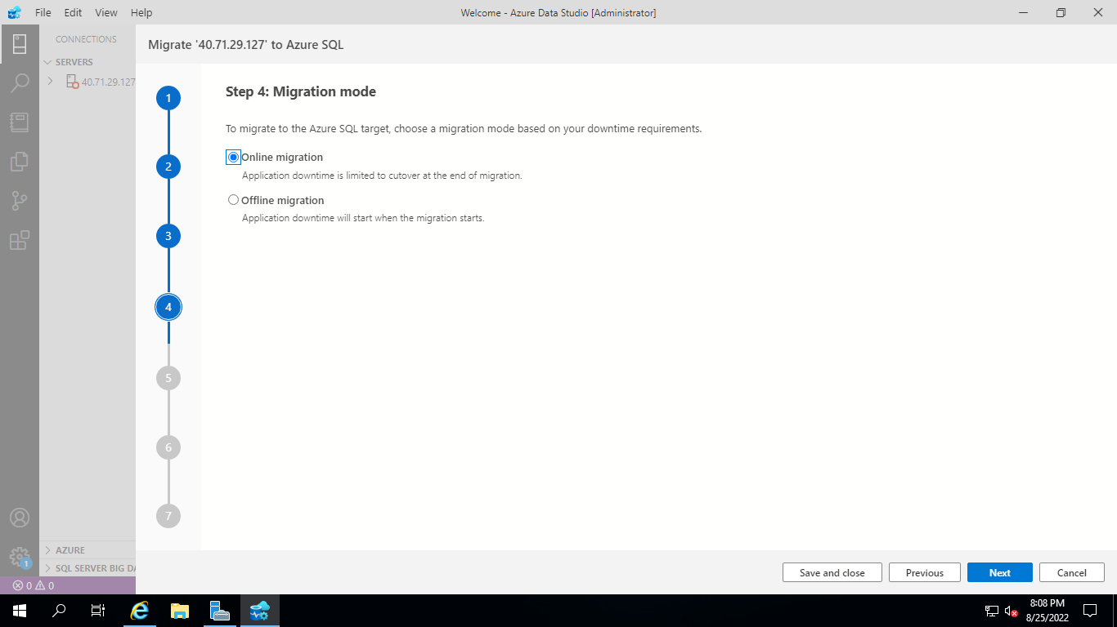

1. Select **Online migration** as the migration mode.
2. Select the location of database backups. Source database backup in an Azure storage blob container.
3. For backups stored in an Azure storage blob container specify the below details of the **Target database name**, **Resource group**, **Azure storage account**, **Blob container** and **Last backup file from** the corresponding drop-down lists.

| **Field** | **Description** |
| --- | --- |
| **Target database name** | The target database name can be modified if you wish to change the database name on the target during the migration process. |
| **Storage account details** | The resource group, storage account and container where backup files are located. |
| **Last Backup File** | The file name of the last backup of the database that you are migrating. |

Provide Storage Account Blob Container details

**Resource Group “Provide Resource Group Name”**

**Storage Account “Provide Storage Account Name”**

**Blob Container “labexercise”**

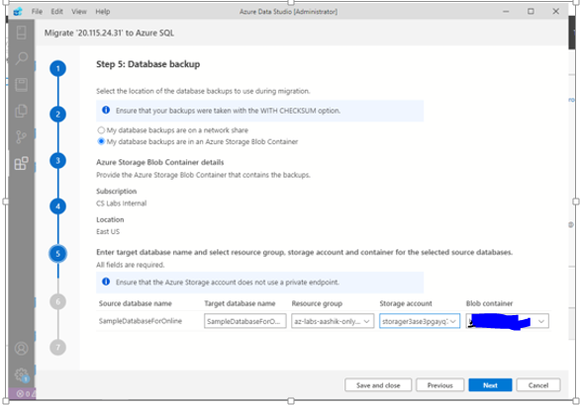

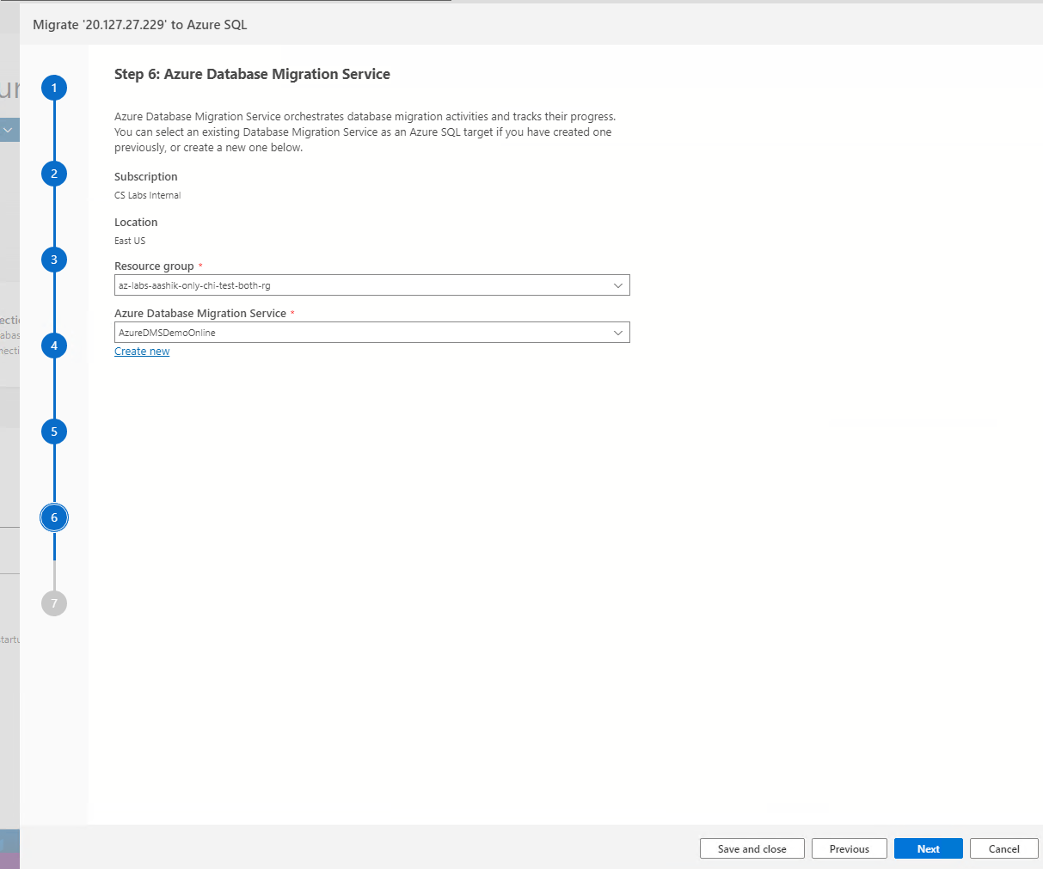

**Create Azure Database Migration Service**

1. Create a new Azure Database Migration Service or reuse an existing Service that you previously created.
2. Select the **Resource group** where you have an existing DMS or need to create a new one. The **Azure Database Migration Service** dropdown will list any existing DMS in the selected resource group.
3. To create a new DMS, select on **Create new**.
4. On the **Create Azure Database Migration Service**, screen provide the name for your DMS and select **Create**.

Note: Please provide the name of new DMS as ‘**onlinedms**’

Click **Done** once you create a Data Migration Service

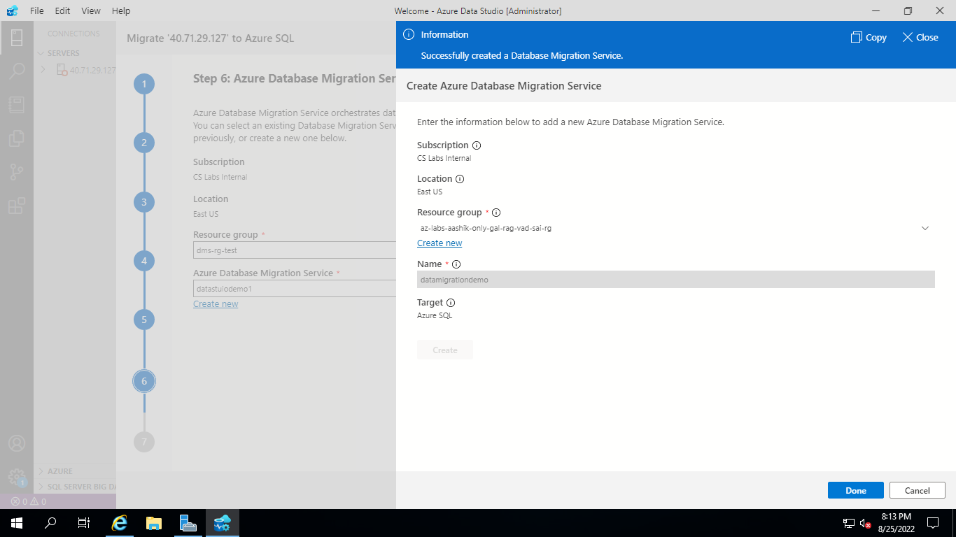

Click **Next**



Select **Start migration**.

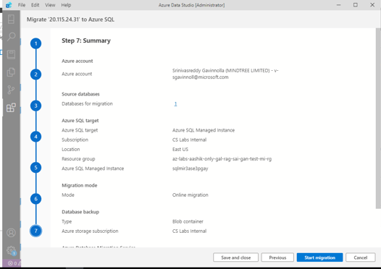

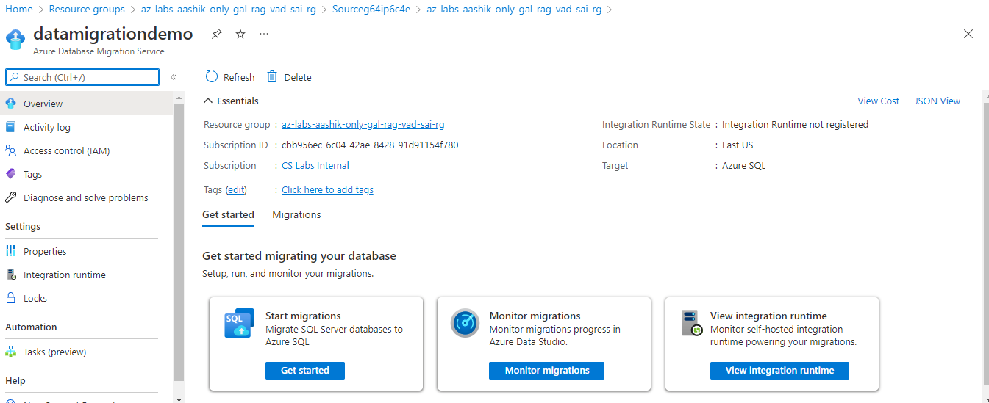

**Monitor the migration**

**Open newly created ‘onlinedms’ and select Monitor migrations**

On the migration activity screen, select **Refresh** to update the display until the **Status** of the migration shows as **Completed**.

**Monitor your migration**

1. On the **Database Migration Status**, you can track the migrations in progress, migrations completed

After all database backups are restored on SQL Server on Azure Virtual Machine, Complete cutover button will be enabled in Azure DMS to ensure the migrated database is ready for use. Please select Complete Cutover button.

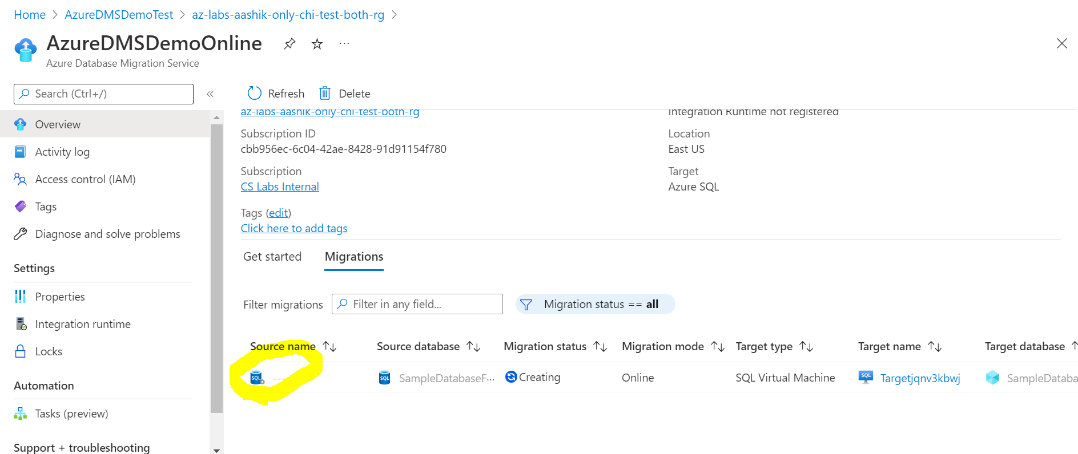

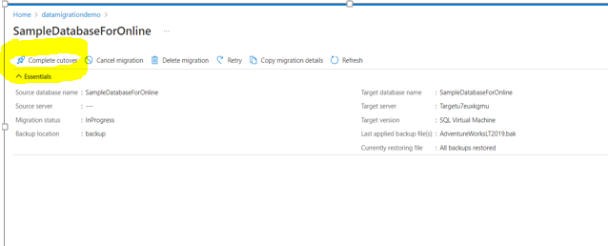

Select **Complete cutover**.

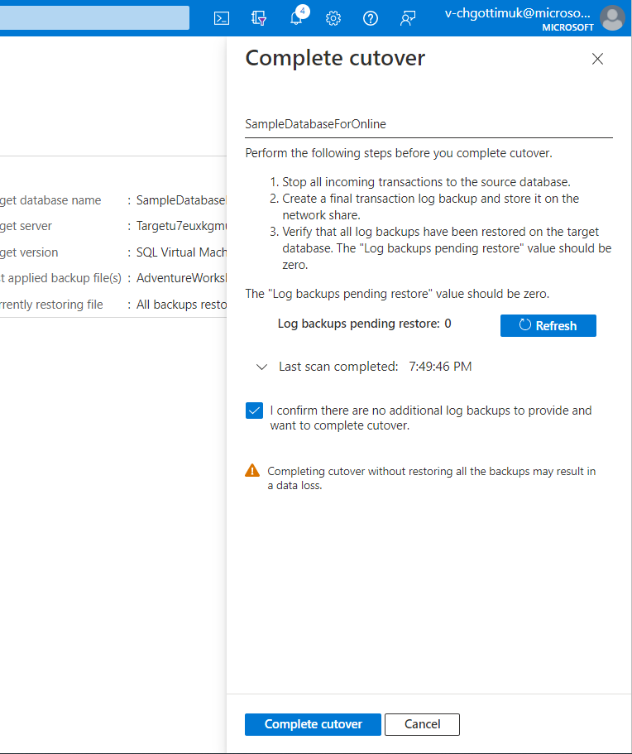

Select **Complete cutover**.

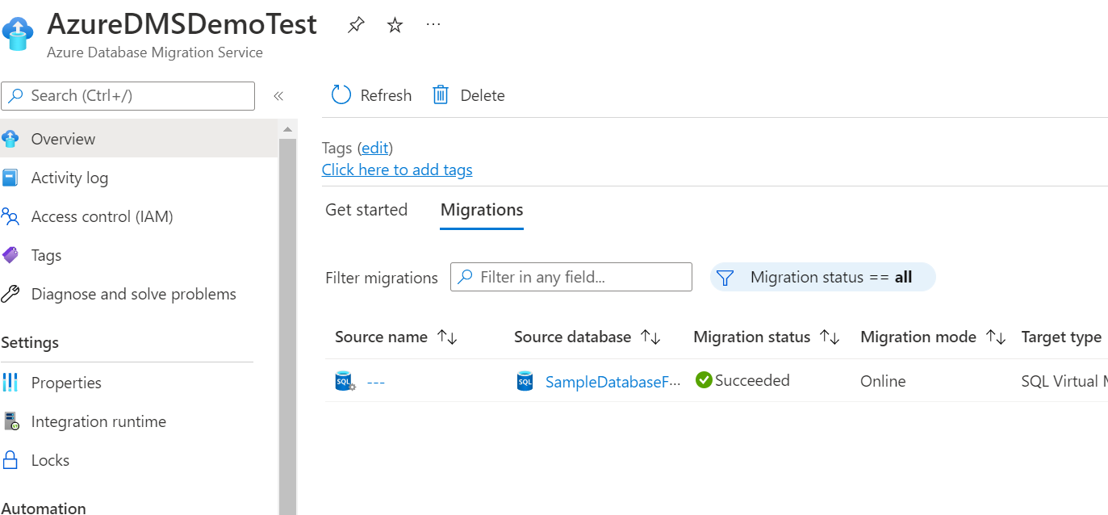

**Post Migration Validation Steps**

**Go to SQL Managed Instance in Azure portal**

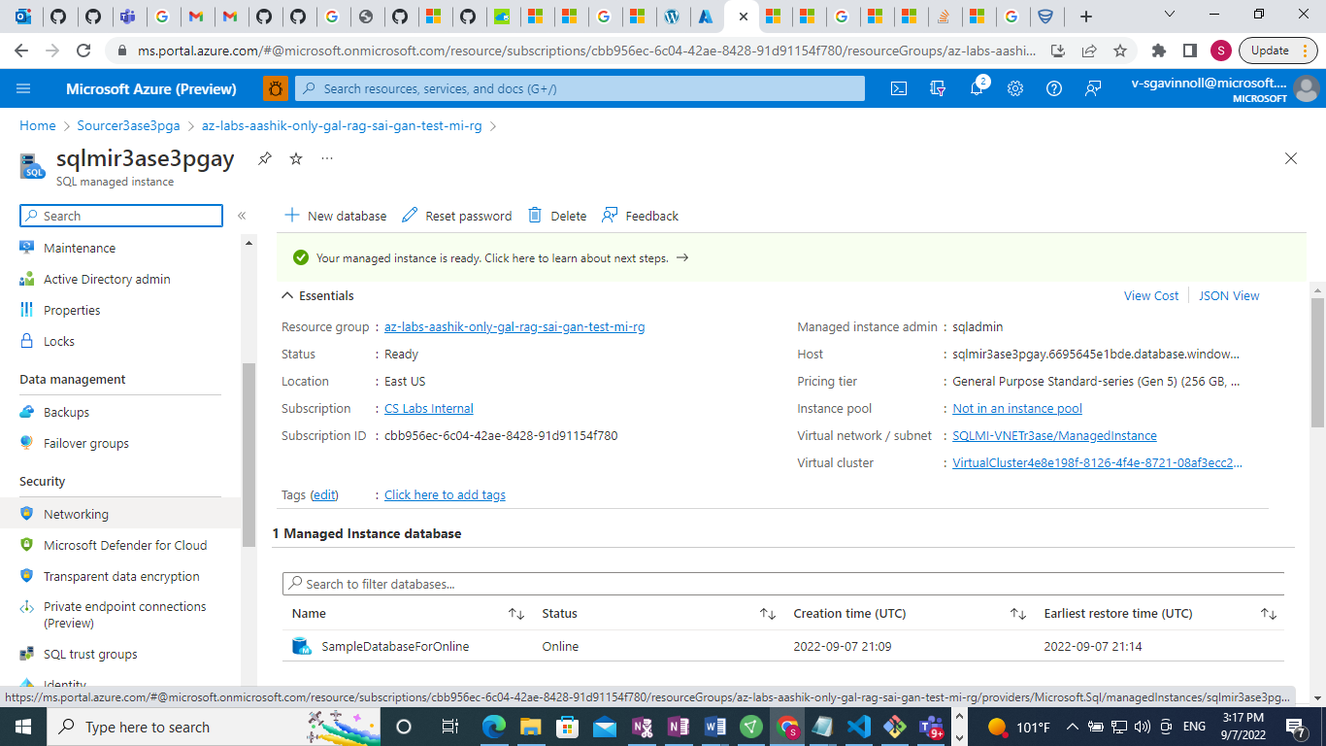

Enable **Public Endpoint** and **Save**

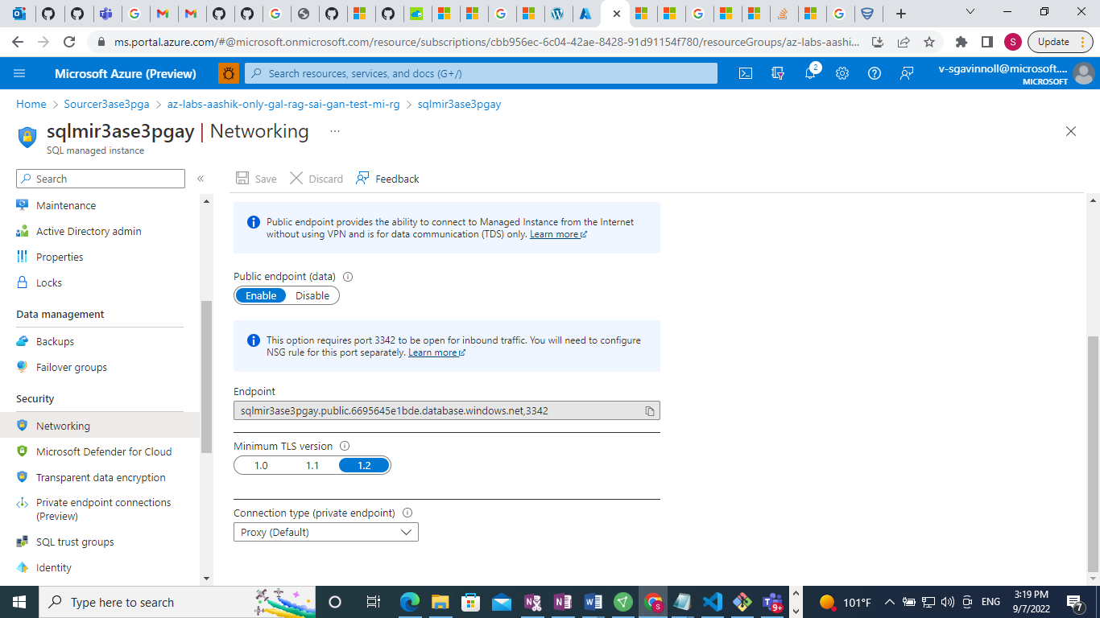

Then open network section in SQLMI Network Security Group

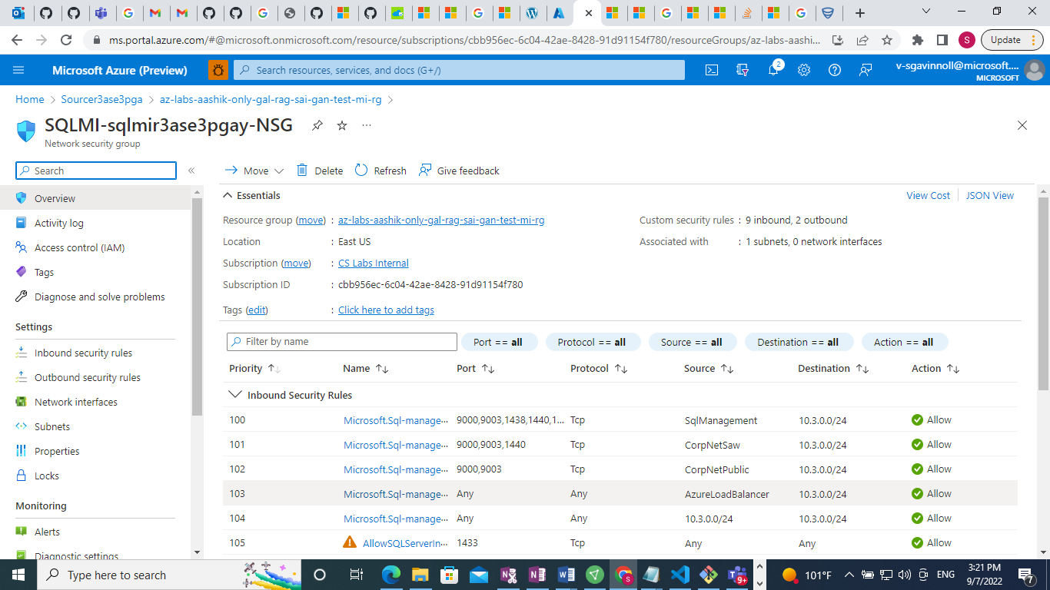

Then **Add** Inbound Security rule with port **3342**

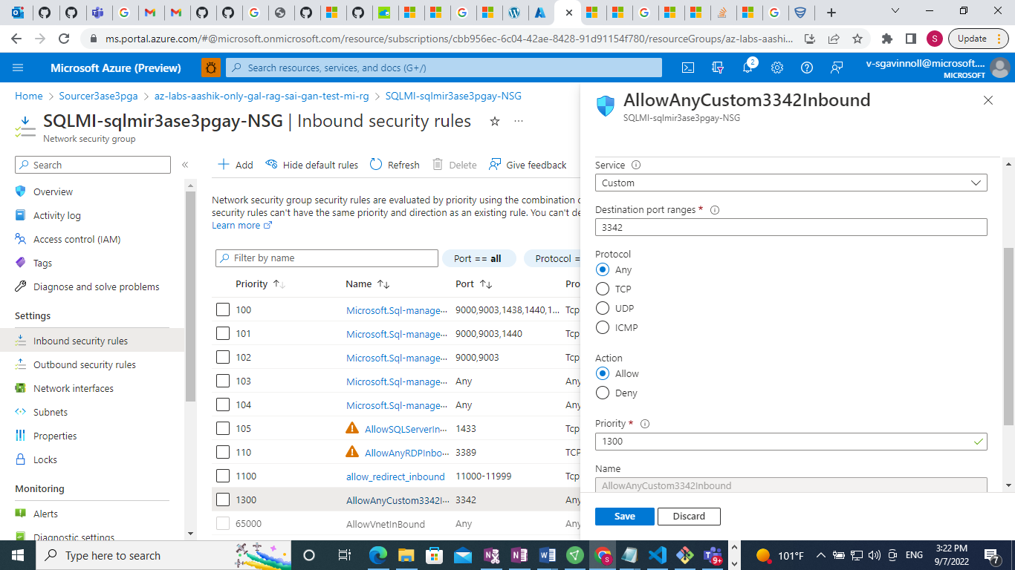

Then **Save**

Then go to **Networking section of SQL MI**

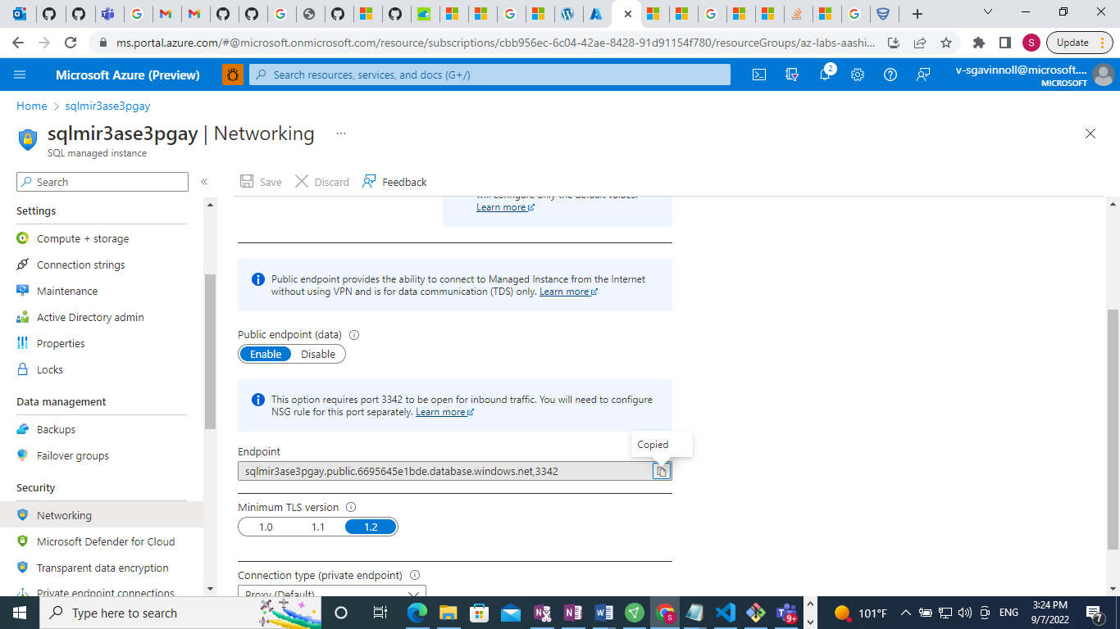

Copy FQDN

**sqlmir3ase3pgay.public.xxxxxx.database.windows.net,3342**

Then Search **Microsoft SQL Managed Studio 18**

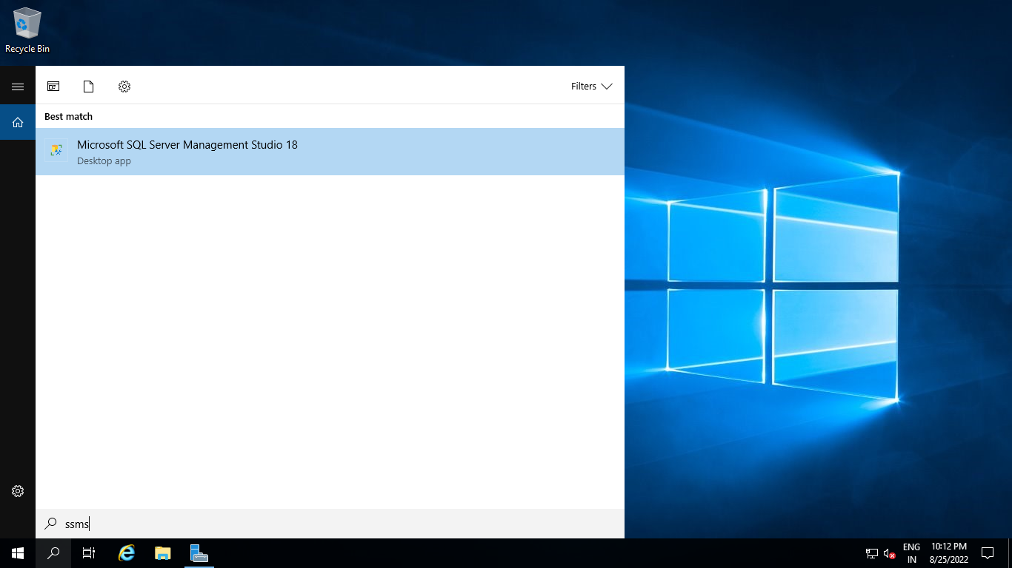

Select **Connect to login SSMS**

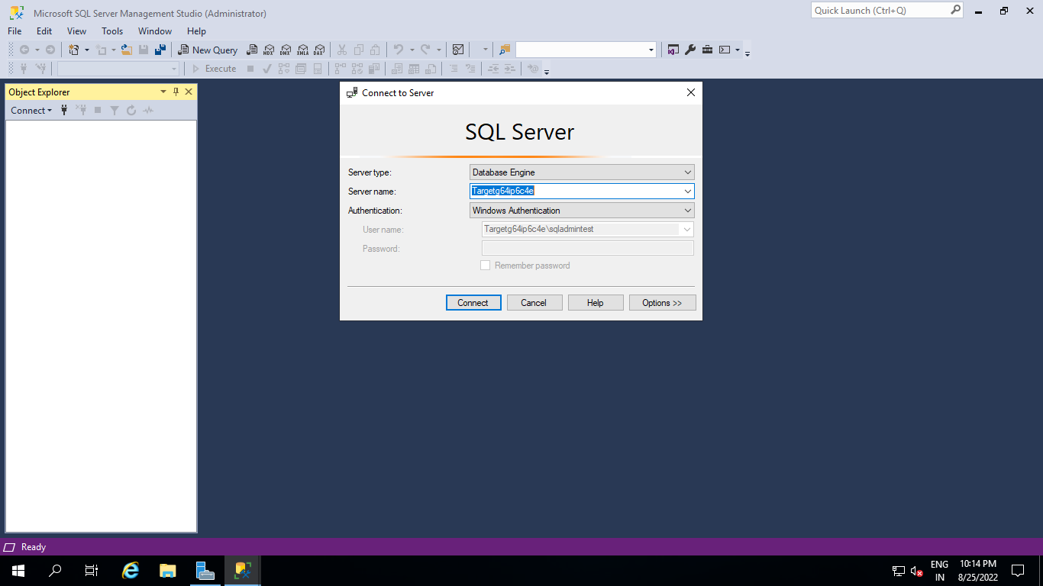

Then Select **Query editor** and provide SQL Credentials to run SQL commands

**Execute below SQL Query:**

**Query:**

select schema_name(tab.schema_id) + '.' + tab.name as [table],

sum(part.rows) as [rows] from sys.tables tab

inner join sys.partitions part on tab.object_id = part.object_id

where part.index_id IN (1, 0)

group by schema_name(tab.schema_id) + '.' + tab.name

order by sum(part.rows) desc

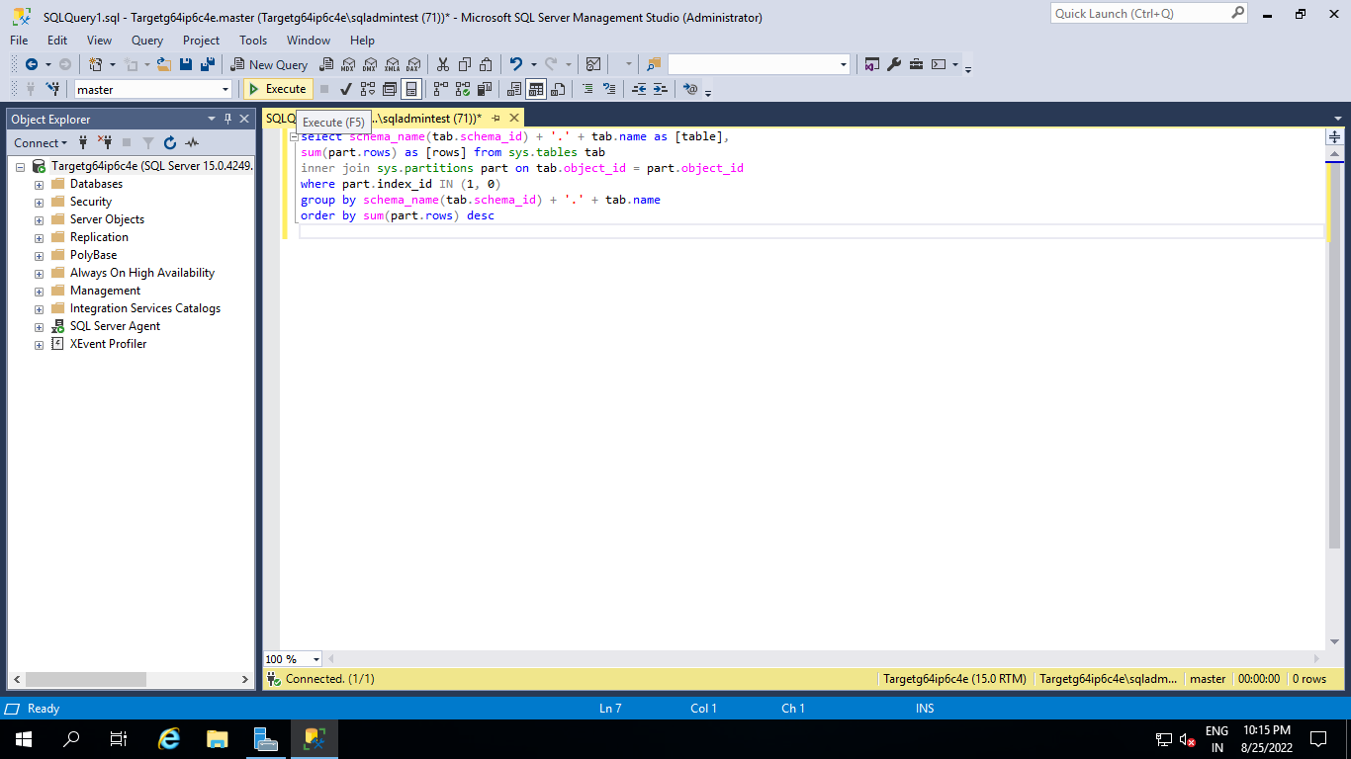

**Please validate output with below parameters.**

**Output:**

table, rows

SalesLT.Customer,847

SalesLT.ProductDescription,762

SalesLT.ProductModelProductDescription,762

SalesLT.SalesOrderDetail,542

SalesLT.Address,450

SalesLT.CustomerAddress,417

SalesLT.Product,295

SalesLT.ProductModel,128

SalesLT.ProductCategory,41

SalesLT.SalesOrderHeader,32

dbo. BuildVersion,1

dbo.ErrorLog,0

**Offline Migration Steps:**

Search **Azure Data Studio** and Launch.





Go to **Extensions**



Select **Azure SQL Migration** Extension and Install



Then go to **Command Palette**





Type Azure SQL Migration: **Migrate to Azure SQL then Enter**

Provide Source Server **Public IP address**

Authentication Type: **SQL Login**

Provide SQL Username: **sqladmin** and Password: **Password@123**

Select **Connect**



Select **SampleDatabaseForOffline**

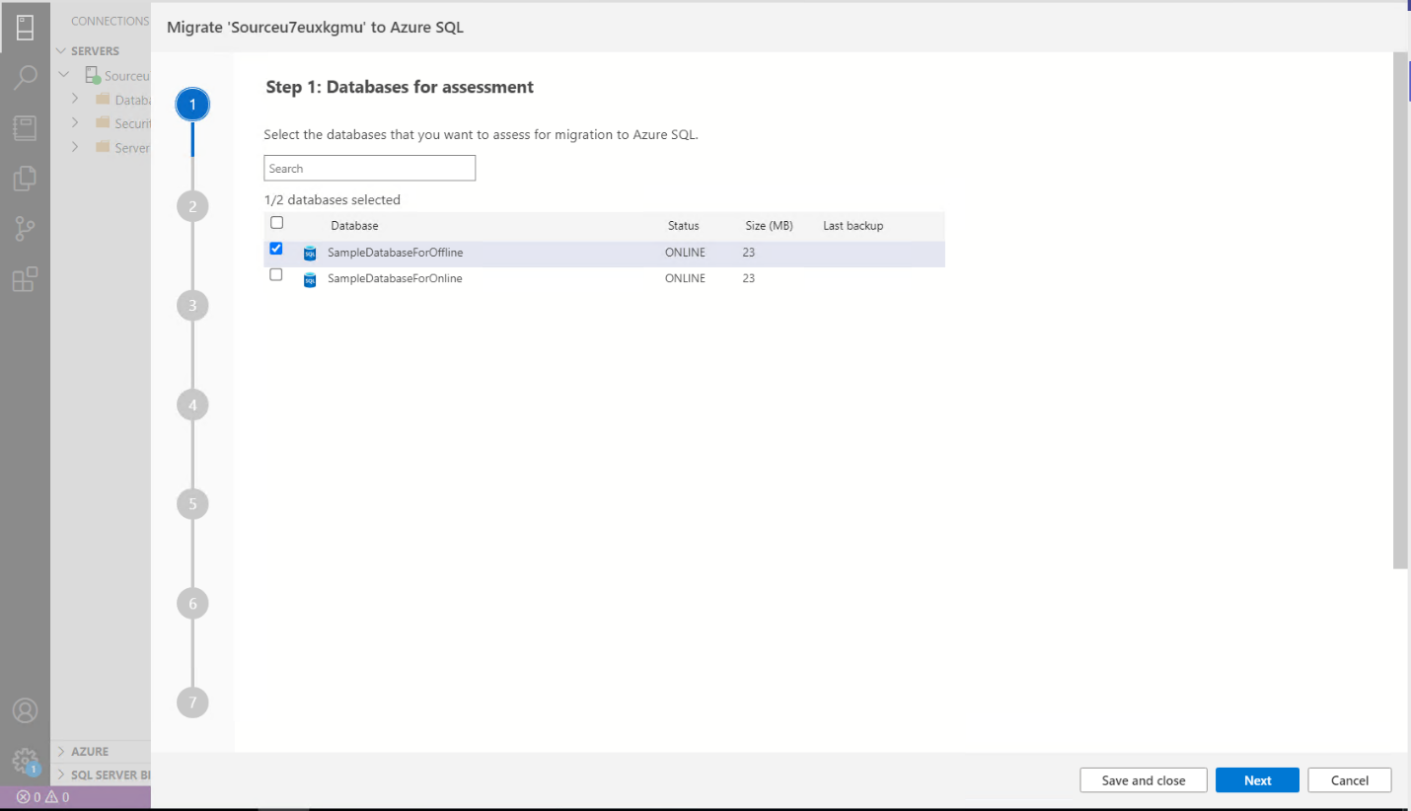

Select **Azure SQL Managed Instance**



Then Select **View/Select**

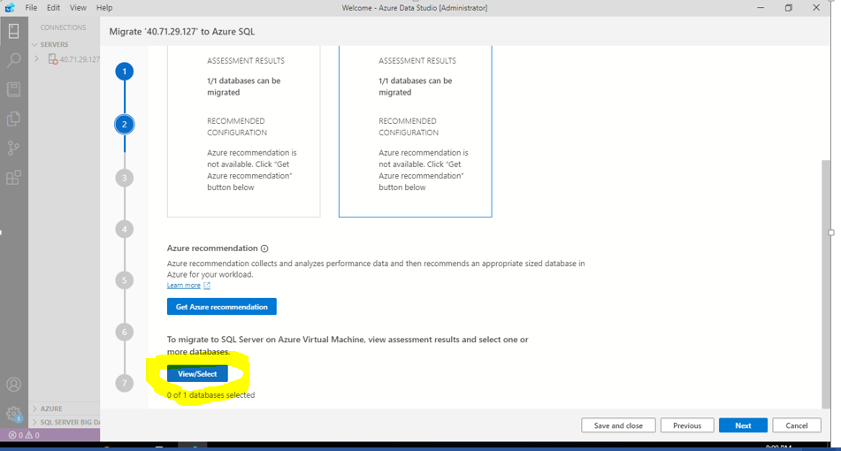

Choose **SampleDatabaseforOffline** and click on select

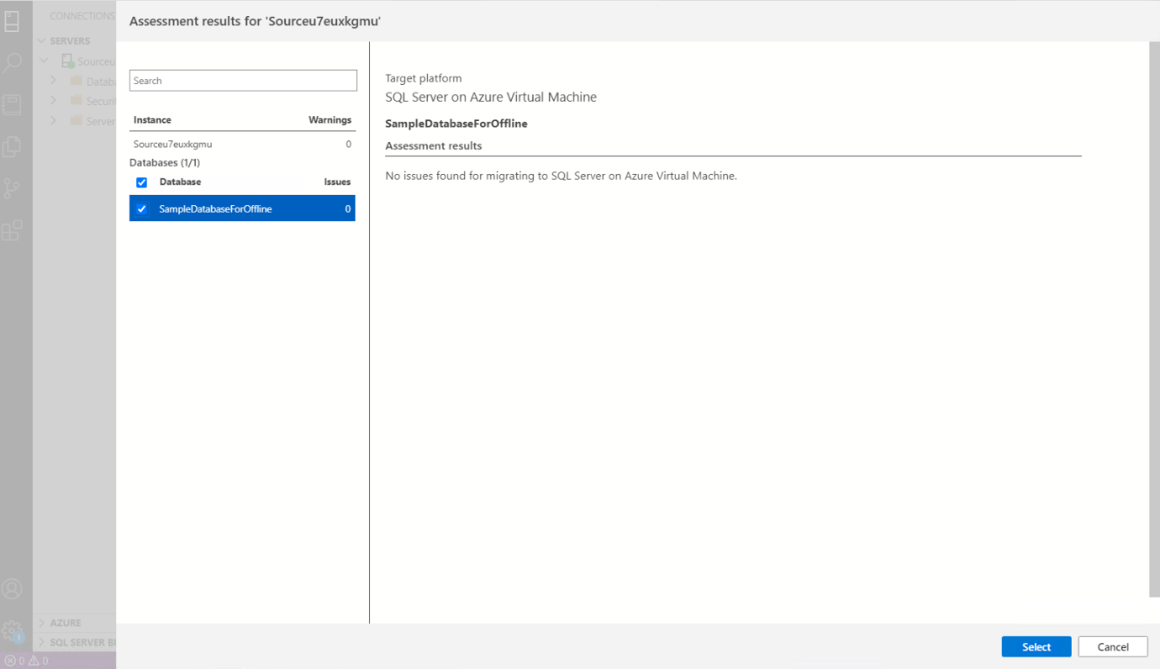

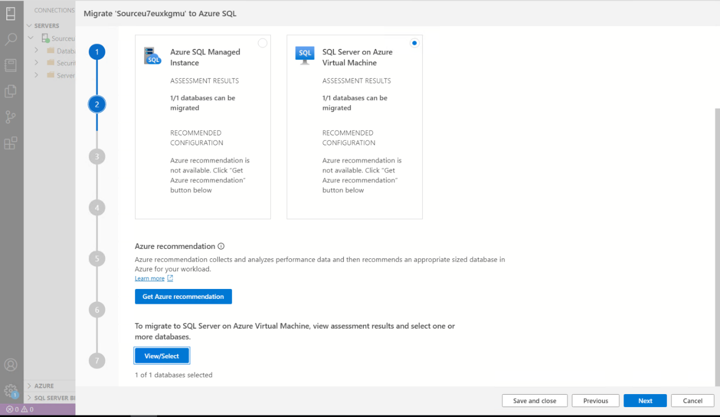

Click **Next**

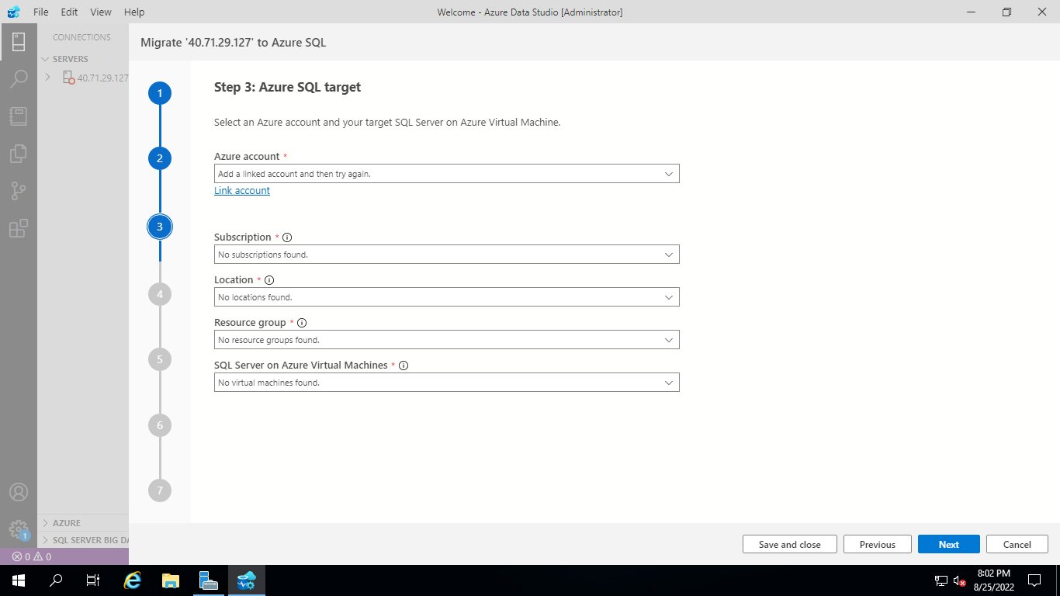

Click on **Add an Account**

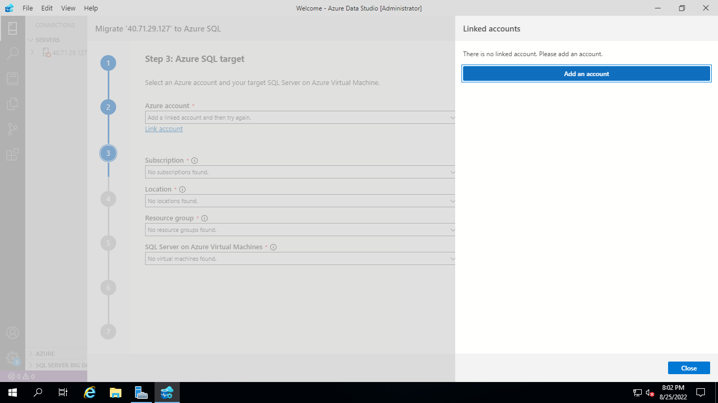

 Provide **Azure Portal Login** Details

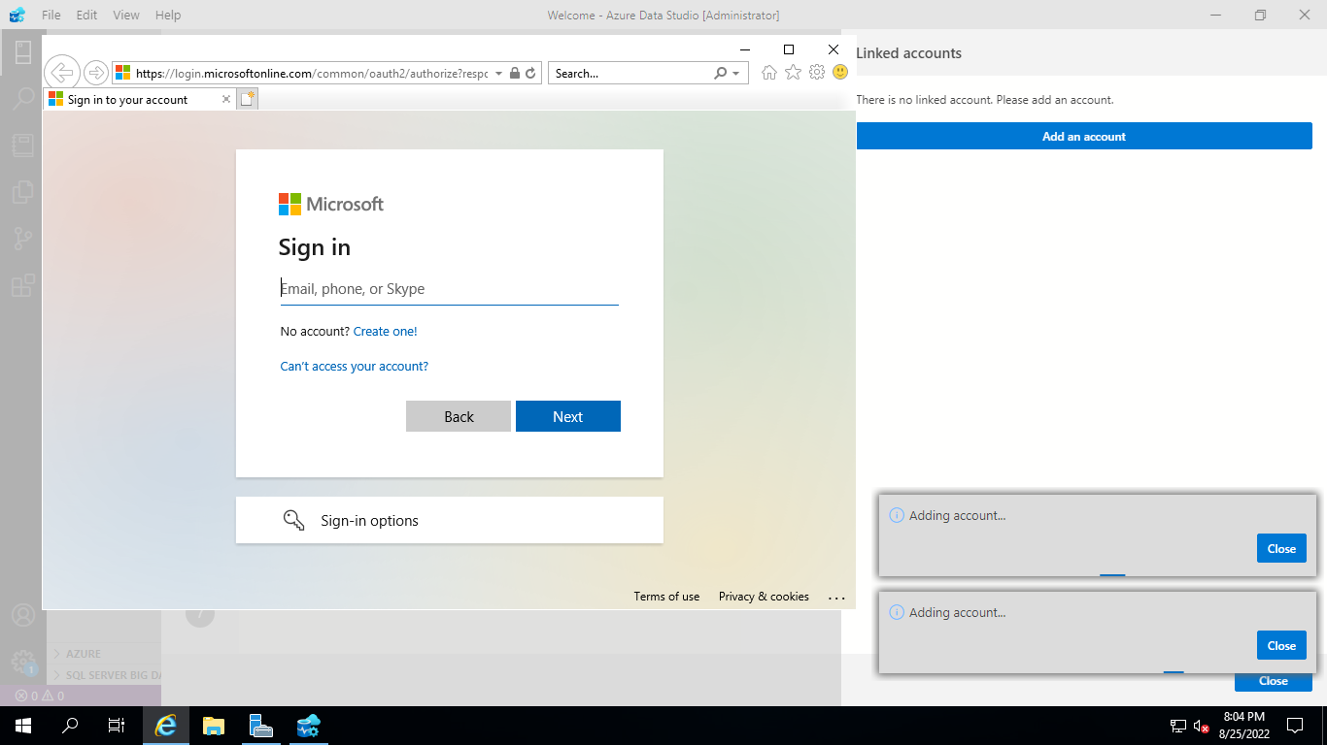

Once you are logged in then click **close**

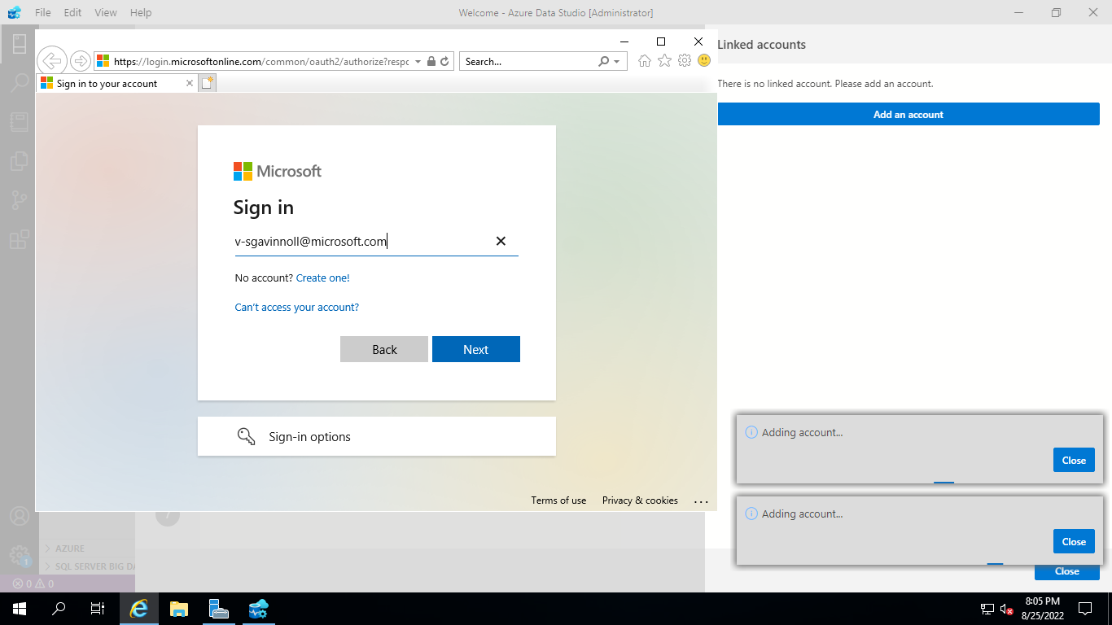

Click **Next**

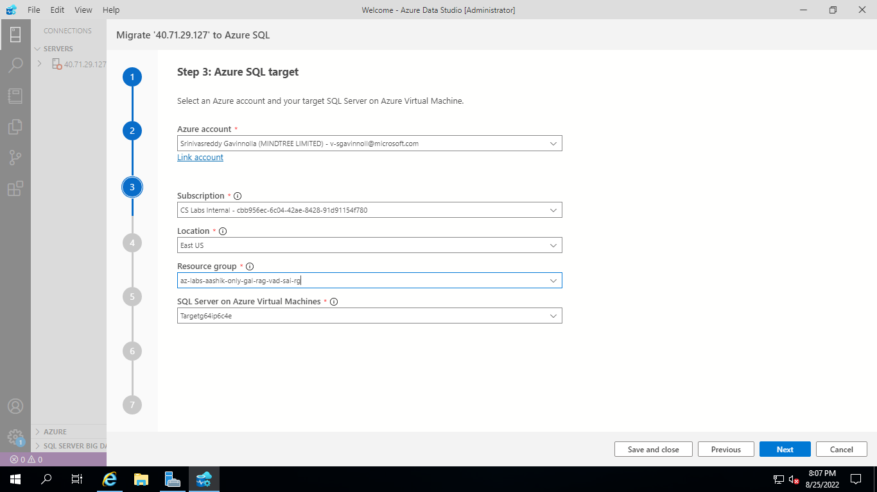

Select **Offline Migration**

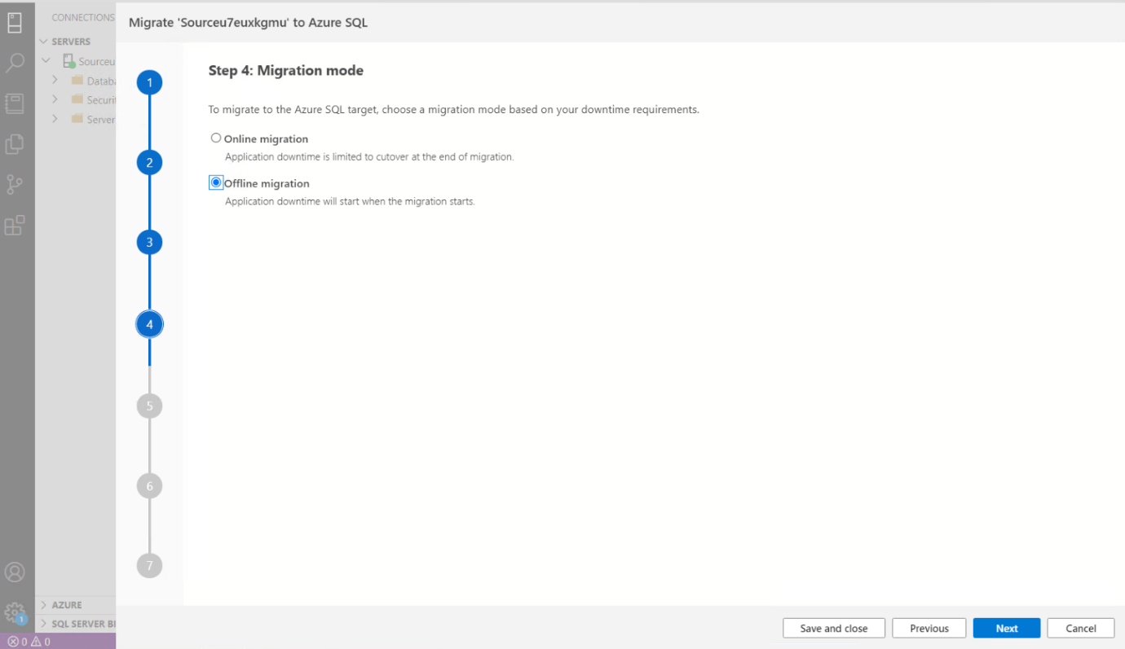

Select Target SQL MI Details:

**Subscription: Subscription Name**

**Location: East US**

**Resource Group: Target SQL MI Resource Group**

**Azure SQL Managed Instance: Target SQL Managed Instance Name**

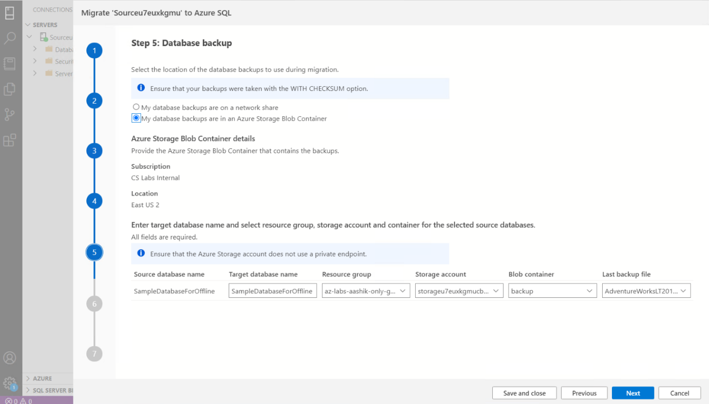

1. Select **Offline migration** as the migration mode.

2. Select the location of database backups. Source database backup in an Azure storage blob container.

3. For backups stored in an Azure storage blob container specify the below details of the Target database name, Resource group, Azure storage account, Blob container and Last backup file from the corresponding drop-down lists.

|  |  |
| --- | --- |
| Field | Description |
| **Target database name** | The target database name can be modified if you wish to change the database name on the target during the migration process. |
| **Storage account details** | The resource group, storage account and container where backup files are located. |
| **Last Backup File** | The file name of the last backup of the database that you are migrating. |

Provide Storage Account Blob Container details

**Resource Group “Provide Resource Group Name”**

**Storage Account “Provide Storage Account Name”**

**Blob Container “labexercise”**

Then Click **Next**  
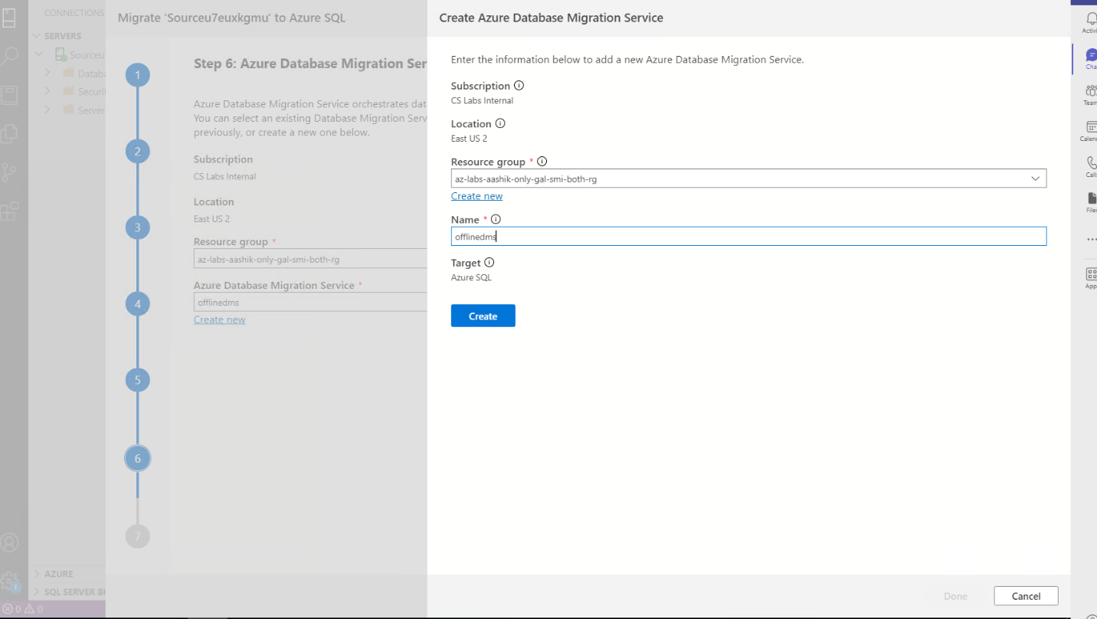

**Create Azure Database Migration Service**

1. Create a new Azure Database Migration Service or reuse an existing Service that you previously created.

2. Select the **Resource group** where you have an existing DMS or need to create a new one. 3. The **Azure Database Migration Service** dropdown will list any existing DMS in the selected resource group.

4. To reuse an existing DMS, select it from the dropdown list and the status of the self-hosted integration runtime will be displayed at the bottom of the page.

5. To create a new DMS, select on **Create new**.

6. On the **Create Azure Database Migration Service**, screen provide the name for your DMS and select **Create**.

**Note: Please provide the name of new DMS as ‘offlinedms’**

Click **Done**

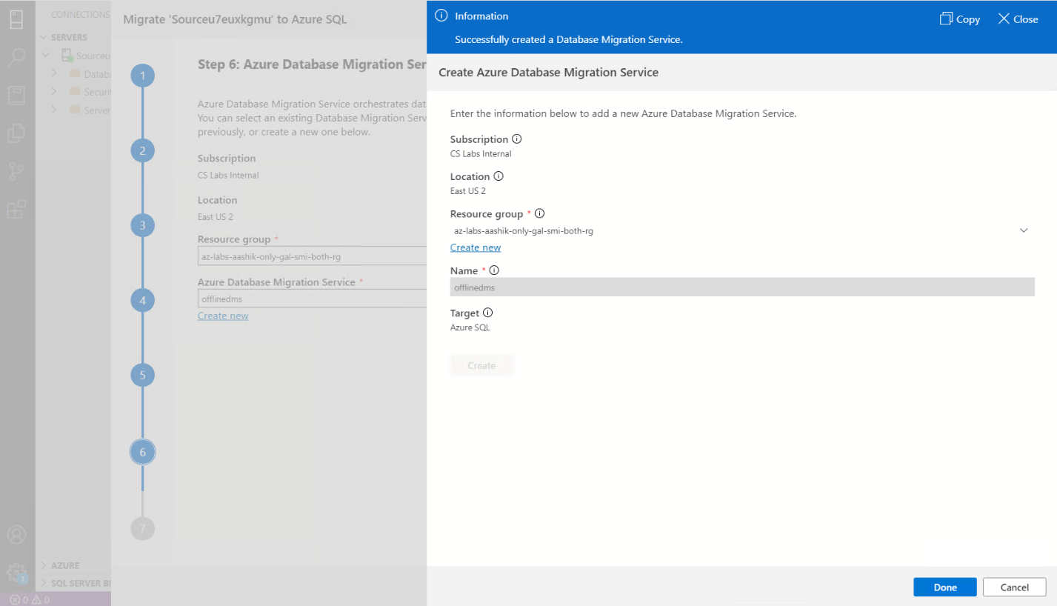

Click **Next**

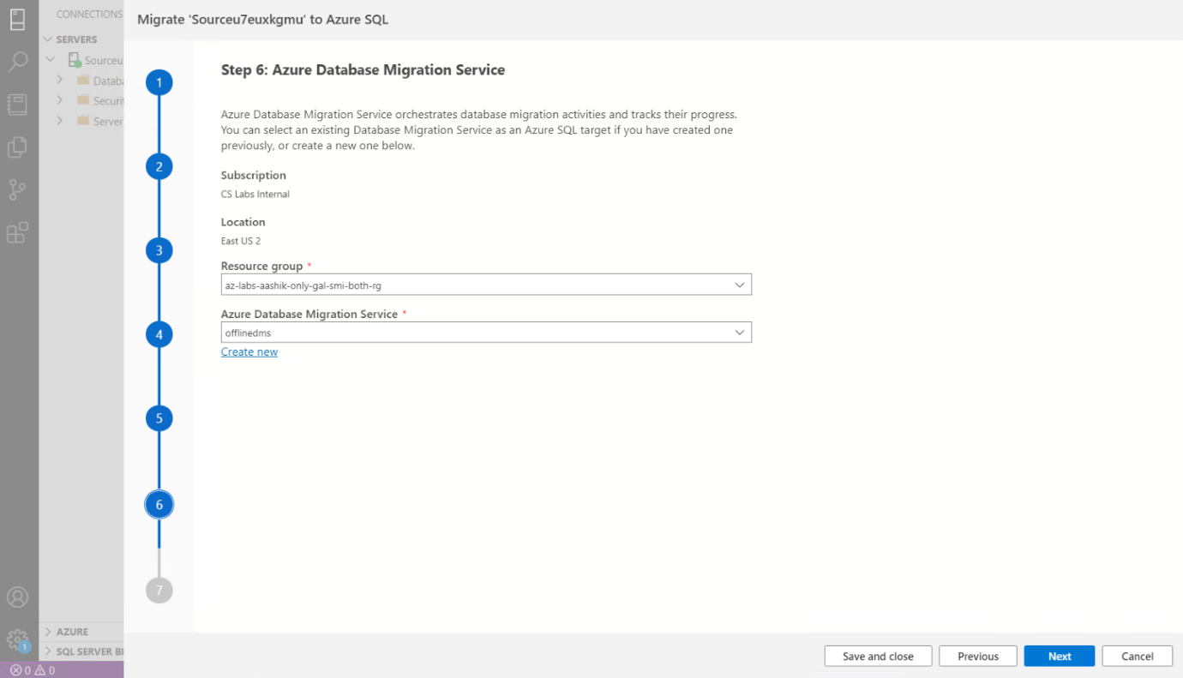

Start **Migration**

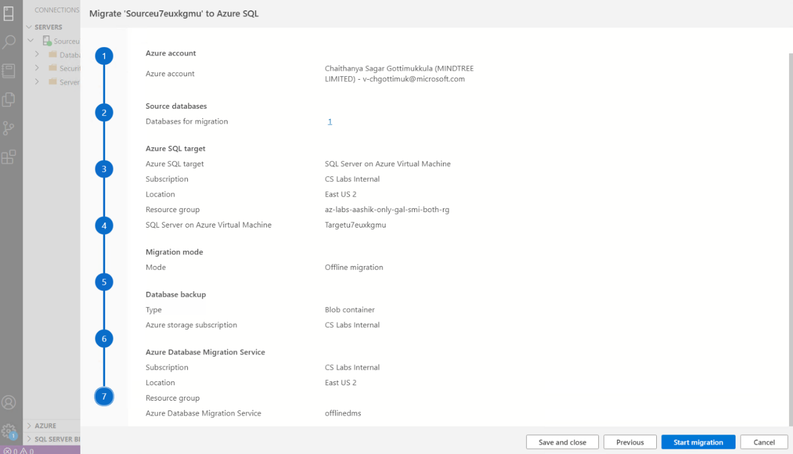

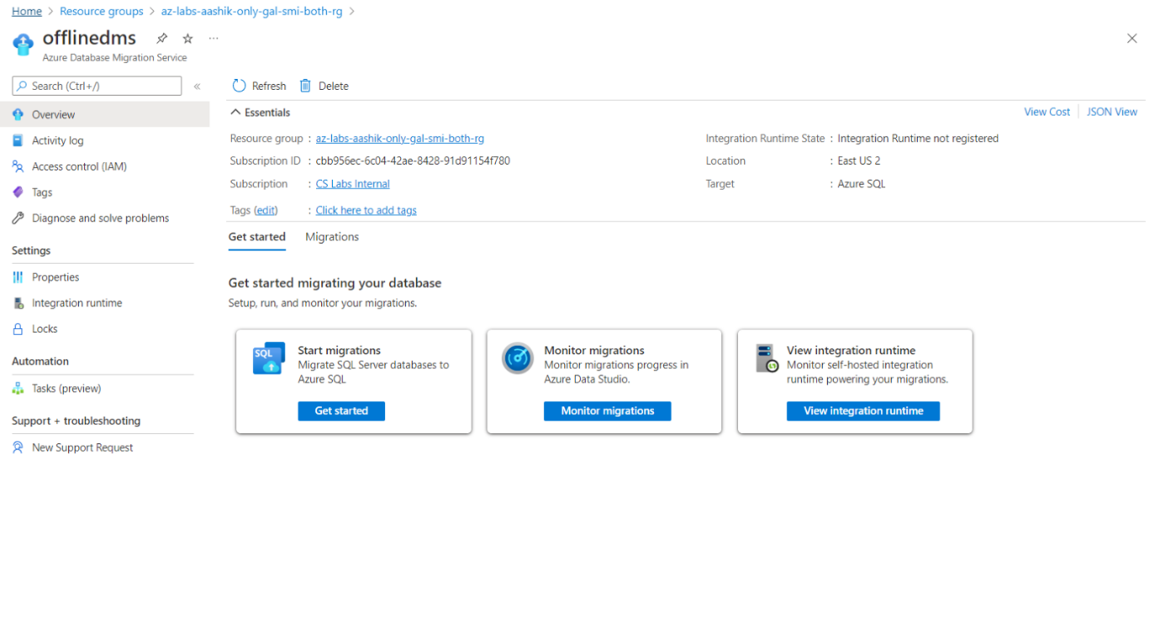

**Monitor the migration**

Open **‘offlinedms’** and select **Monitor migrations**

On the migration activity screen, select **Refresh** to update the display until the **Status** of the migration shows as **Completed**.

**Monitor your migration**

1. On the **Database Migration Status**, you can track the migrations in progress, migrations completed

  
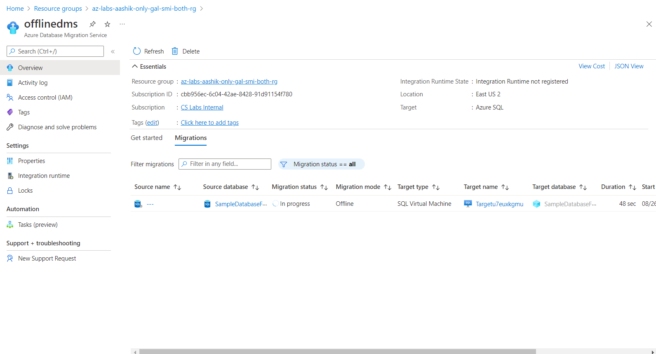

Hit **Refresh**

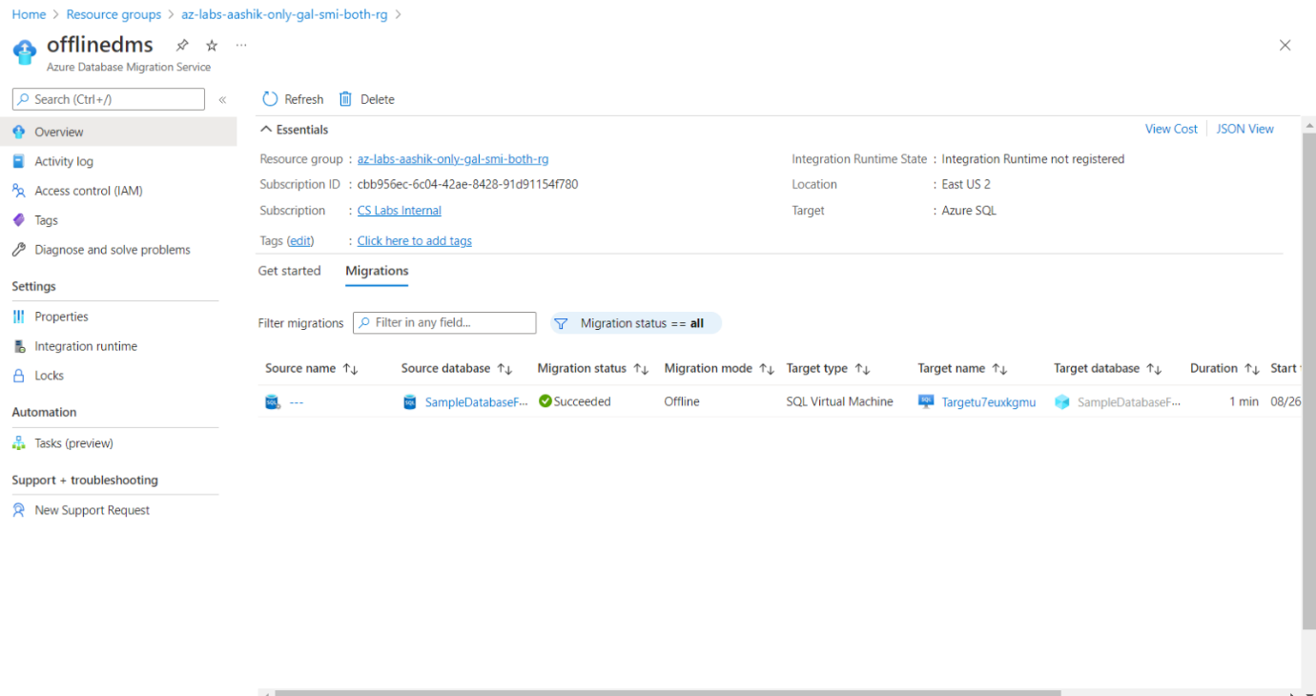

**Post Migration Validation Steps**

**Go to SQL Managed Instance in Azure portal**



Enable **Public Endpoint** and **Save**



Then open network section in SQLMI Network Security Group



Then **Add** Inbound Security rule with port **3342**



Then **Save**

Then go to **Networking section of SQL MI**



Copy FQDN

**sqlmir3ase3pgay.public.xxxxxx.database.windows.net,3342**

Then Search **Microsoft SQL Managed Studio 18**



Select **Connect to login SSMS**



Then Select **Query editor** and provide SQL Credentials to run SQL commands

**Execute below SQL Query:**

**Query:**

select schema_name(tab.schema_id) + '.' + tab.name as [table],

sum(part.rows) as [rows] from sys.tables tab

inner join sys.partitions part on tab.object_id = part.object_id

where part.index_id IN (1, 0)

group by schema_name(tab.schema_id) + '.' + tab.name

order by sum(part.rows) desc



**Please validate output with below parameters.**

**Output:**

table, rows

SalesLT.Customer,847

SalesLT.ProductDescription,762

SalesLT.ProductModelProductDescription,762

SalesLT.SalesOrderDetail,542

SalesLT.Address,450

SalesLT.CustomerAddress,417

SalesLT.Product,295

SalesLT.ProductModel,128

SalesLT.ProductCategory,41

SalesLT.SalesOrderHeader,32

dbo. BuildVersion,1

dbo.ErrorLog,0